BLINDFOLD

225 Laurel Avenue, Pacific Grove, CA 93950 (831)649-3505 www.blindandlowvision.org

FALL 2016

NEWS & ANNOUNCEMENTS

Board of Director’s Openings
We have openings for board members and are accepting applications from persons interested in joining our Board. We are seeking prospects with the following skills: human resources, accounting, insurance, fundraising, community connections, or non-profit management.

Please send your interest to Ron Kihara at BVIC, 225 Laurel Ave, Pacific Grove, CA 93950. We are looking forward to hearing from you!

Annual Support Campaign: $100,000 Goal
Fall marks the beginning of our annual support campaign to raise funds to support our highly valued services to persons who are blind or visually impaired. This year the Board has set a goal of $100,000 and has started the campaign by collectively donating more than $25,000!

If you have not received a call from a board member or letter in the mail, one is on its way! We hope you will be generous in helping us achieve our goal.

Did you know, Nov. 11th to Dec. 31st you can make your donation on-line through the MCGives 2016 campaign and it will be partially matched? Watch for the special giving edition of the MC Weekly in early November and increase your impact by donating to BVIC through MCGIVES! For more info visit: https://www.montereycountygives.com/rfp/

Pacific Grove Lions Club Meeting: Oct. 19
The District 4-C6 Lions are hosting informational meetings about revitalizing the Pacific Grove Lions Club. There will be two meetings held on Wednesday, October 19th at 3pm and 6pm at BVIC’s upper building. If you are interested in learning about Lions Clubs or joining the PG Club, please join us. If you have any questions please call the District Governor, Barbara Chamberlain at 831-251-6121 or email: barbarac@got.net.

Save the Date – Motorcycle Show Oct. 2nd
The Old Capitol Lions Club is hosting the “Monterey Peninsula Antique Motorcycle Show” from 9:00am – 3:00pm on Sunday, October 2nd at the Moose Lodge on Canyon del Rey Blvd, Del Rey Oaks. Admission is FREE. Food and beverages will be on sale. Proceeds will benefit BVIC.

Register your motorcycle online at www.oclions.club. For more information, please contact John Dick at 831-646-4580 or john.dick@mountztorque.com or visit: www.oclions.club/vintage-motorcycle-show.

Save the Date: Saturday, Dec. 3rd
Christmas Store Auction & Health Fair
Saturday, Dec. 3rd from 10am – 2pm

This year the Country Store Auction is being changed into a Christmas Store Auction & Health Fair. We will have all the usual yummies and arts for sale, along with a silent auction to raise funds to support our free services. Each auction item will have a “buy-it-now” price so you can snatch it up as a special holiday gift for someone or yourself!
We will have the Lions District 4-C6 A.J. Robinson Mobile Screening Unit on site as a community outreach project. The unit allows us to provide screening for vision, hearing, and diabetes.

If you would like to donate items for the auction, volunteer the day of the event, or participate in the screening please contact Diana Trapani at BVIC by calling 831-649-3505. Admission is FREE.

A Bit of Humor
“When we started Apple, Steve Jobs and I talked about how we wanted to make blind people as equal and capable as sighted people, and you’d have to say we succeeded when you look at all the people walking down the sidewalk looking down at something in their hands and totally oblivious to everything around them!”
- Computer tech pioneer Steve Wozniak.
(June 2016 aarp.org/bulletin)

Apple Store Discover Accessibility Classes
The BVIC is pleased to collaborate with the Apple Store, Del Monte Shopping Center to provide "Discover Accessibility" workshops on the accessibility features of the Mac and iPhone/iPad.
To sign-up, visit their website: https://concierge.apple.com/workshops/R305/en_US/.

Please be sure to thank them for offering this special service!

New Strategic Plan
On August 11th the Board of Directors adopted a new strategic Plan with updated vision, mission and values. The Board expresses their sincere thanks to Roger Barney, Consultant for leading the process and to the committee members: Celia Barbarena, Ken Hunter, Russ Hatch, Ron Kihara, Mona Schoenwisner, Marty Lipp, Sam Kelley, Moonset Yu, Cheri Padin, and Diana Trapani. Below is an overview of the plan.

VISION
BVIC’s vision is to be the go to place for information, education and services for the visually impaired in Monterey County.

MISSION
BVIC’s mission is to empower the blind and visually impaired toward independent living through responsive education, support services and skills training.

VALUES
Client Focused
Compassionate
Responsive
Respect
Integrity
Trust
Relevance
Professionalism
Organizational Excellence
Results & Outcomes
Responsible Growth
Teamwork & Collaboration

Goal 1: Staffing
G1-A: Hire two full-time program staff or a combination of part-time to fill the current openings. Status: Two full-time staff hired and on board!
G1-B: Evaluate job descriptions and salary levels of current staff.
G1-C: Evaluate skills of new staff and volunteers to propose possible new services. (Ties with G2-A).
G1-D: Evaluate need of and plan for additional program staff as we work on Goal #2.
G1-E: Evaluate need of and plan for additional administrative staff as we grow.
G1-F: Investigate what would be involved in establishing a pension plan for staff.

Goal 2: Programming
G2-A: Evaluate skills of new staff and volunteers to propose possible new services. (Ties with G1-C).
G2-B: Determine new service options.
Goal 3: Infrastructure
G3-A: Purchase, network and install new technology for all staff. Status: Complete.
G3-B: Purchase, populate with history, and begin utilizing a donor database to track donations, and other constituent related data. Status: Almost complete.
G3-C: Purchase, populate with history of active clients, and begin utilizing a case management software program. Status: Almost complete.
G3-D: Review, update and/or create new organizational documents and consider which Board committees need to be formalized and/or established to support the changing role of the Board into a formal working board; create board commitment check-list and job descriptions.
G3-E: Program evaluation will be formalized, tracked with new case management software and other means, to improve outcome reporting.

Goal 4: Funding
G4-A: Create a 2-year Annual Fund Development Plan with calendar, which can be updated each year to keep it a two year rolling plan. Status: Complete.
G4-B: Create a formal Legacy Giving Plan and Program. Status: Almost Complete.
G4-C: Double the fundraising income by fiscal year end 2020.
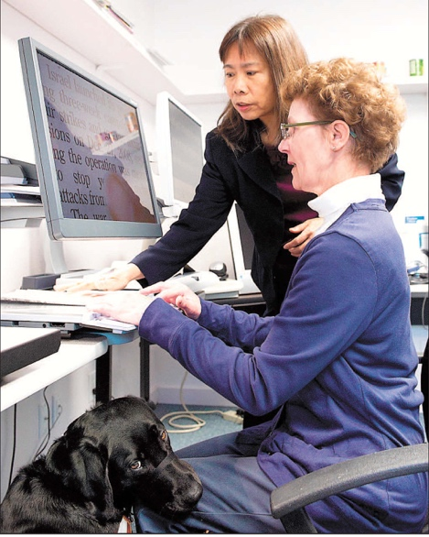
Goal 5: Outreach & Marketing
G5-A: Create and launch a new website. Status: Almost complete.
G5-B: Create and publish a new agency brochure, one in English and one in Spanish. Status: Almost complete.
G5-C: Create an agency video, one in English and one in Spanish. Status: Almost complete.
G5-D: Create and launch an outreach/media plan.

You will notice that many of these goals tie into activities under way the DOR $150,000 grant. Combined, these activities will strengthen BVIC’s infrastructure and poise us for growth and expansion of services. If you have any questions please contact Ron Kihara, Board President or Diana Trapani, Executive Director at the center.
Dr. Yu teaches Sonja Jackson how to use a CCTV so she can continue to read her favorite books.

Farewell and Best Wishes to All
Moonset Yu
My retirement from the BVIC began on September 1st. There are many who I will truly miss, especially the people I have worked with and the clients I have served and visited during the last 14 years.

Like other former BVIC employees, it is time for me to allow another low vision professional to take over this meaningful position of serving people with low vision in the Monterey County area.
Jeannie Cordero, former Program Director hired me as the Low Vision Services Coordinator in the Spring of 2002. At that time, I already had 25 year experiences of teaching students with visual impairment and other disabilities. Working with adults and seniors required a different scope of practices and attitudes which I found to be very satisfying and meaningful.

I was rewarded with hugs and praises by clients/patients who appreciated my work. It was a joy to witness their improvement as they adjusted to life with low vision, but I was equally saddened when someone gave up and choose not to use their adapted skills. Facing vision loss can be a challenge for many. At times I was discouraged, rejected by an individual who was still working through the initial adjustment period. It was a victory when a person was finally ready to learn skills and reconnected with me, sometimes this happened months or even years after the initial visit. Nonetheless I never thought of my work as being just a job. It has been an honor to assist people in meeting the challenges of vision loss.

I am so grateful for the trust bestowed by the board and directors, Jeannie Cordero and Cheri Padin through the years. Dr. Wodecki and I were given the freedom to carry out our professional interests. We created new projects that shared the BVIC’s expertise and strengthened collaboration with eye care professionals, visual aids manufacturers, dealers and local agencies.

The following are examples of some of the projects. The VISTA Program allowed us to evaluate local students with visual impairments and to give them assistive devices. We served as consultants helping Taiwan to establish a low vision center. We were pleased to have trained vision rehabilitation professionals from China. Our Annual Low Vision Care Day was an event that benefitted clients and the community.

I was very happy and fulfilled with my position at the BVIC. This has been because of all of you. Thank you all. Moonset Yu, PhD. CLVT.

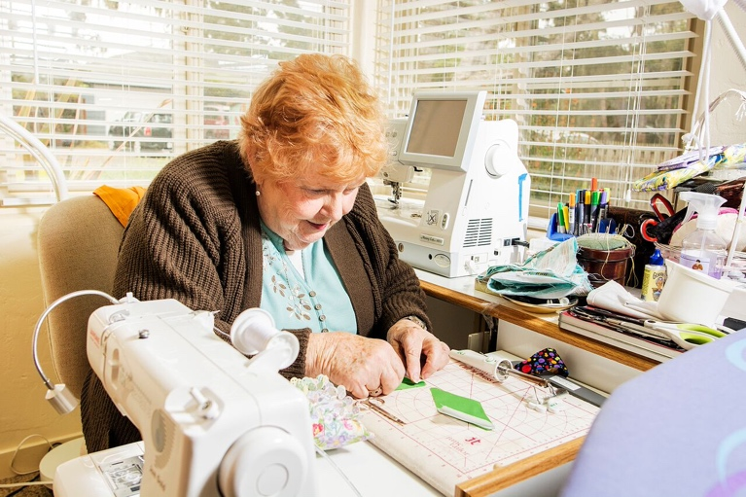
Thanks to alternative skills learned at BVIC, Mona Schoenwisner continues to participate in her favorite hobby – sewing!
Low Vision Clinic
Jenny Swad, CLVT/COMS
I am very pleased to be a new employee of The Blind and Visually Impaired Center. I have had the chance to meet many of you in the office, at our board meetings, support group and luncheons. I hope to meet more of you as we finish out the year with our holiday party and fundraiser.

I bring to you over 20 years of experience in the field of Blind Rehabilitation. I received my Orientation and Mobility degree in 1993 through Western Michigan University.
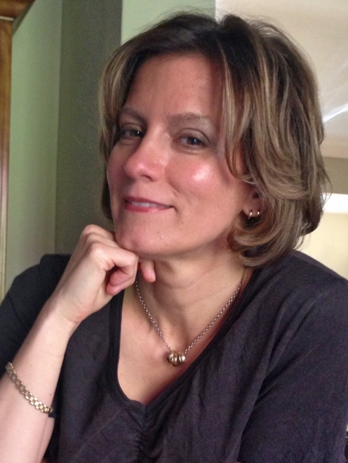
I come to you from the Palo Alto area where I worked in the capacity of a Blind Rehabilitation Outpatient Specialist providing training in mobility, visual and daily living skills. I am most honored to be down in the wonderful community of Pacific Grove serving Monterey County.

I am currently in Moonset's former office and work with our optometrist to provide services in our Low Vision Clinic. I have also attended the Apple trainings and hope to see some of you there.

Please stop into seeing me if you are in the building. I look forward to a bright future with you as we continue to bring creativity and growth to this wonderful organization.

Vision Rehabilitation Services
Karen Levin, VRT
I am delighted to join the staff of BVIC and to be working with clients. I recently moved here from Washington, DC where I was a Vision Rehabilitation Therapist (VRT) with the Columbia Lighthouse for the Blind. While working with them, I provided home assessments to clients all over the city and in nearby Maryland and Virginia. I engaged in support groups in Spanish and provided a 2 week Foundations to Adjust to Blindness (FAB) class along with O&M colleagues where people learned independent living skills.
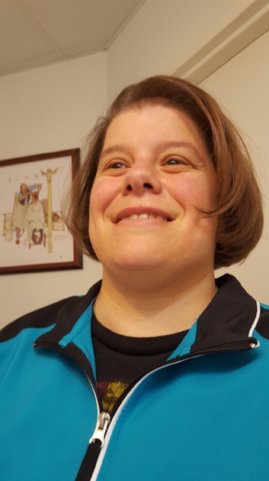
I have a bachelor's degree in occupational therapy and a master's in VRT. I did an internship at a VA hospital in Pennsylvania where earlier I was a teacher’s assistant at a school for children with severe cerebral palsy and later was an educational aide in American Sign Language (ASL) classes at a Washington high school. I have basic ASL skills but am fluent and literate in Spanish. I am looking forward to providing services to our Spanish speaking clients.

I am delighted to be living again in California again where I began elementary school. Now, I am happy to be living on the Monterey Peninsula and am looking forward to meeting you, offering classes, and participating in the Monterey community.

Rehabilitation Assistant
Samantha Kelley
Every time I am in my car driving, I listen to the BBC. Typically, it is a newscast or a special segment involving the goings-on around the world. Last week, however, I happened upon a different broadcast. I tuned into the sound of a city; there were people talking, cars passing, cars honking, a bird chirping here and there. This went on for a while and I began to wonder if it was a broad-casting glitch. Just then, I heard Peter White chime in. It turns out that I had tuned into a show called Blind Man Roams the Globe and was seeing San Francisco through the eyes of a blind man: his ears.

White describes it best: “Having been born blind, I’ve always travelled blind – and for me, sightseeing is more a case of ‘sound-hearing.’ Put simply, things that don’t make much noise aren’t much use to me. Views, paintings, buildings (unless they have a good echo), leave me rather cold. And yet, I’ve always loved travelling.”

As BBC’s Disability Affairs Correspondent, White began his series because, what better way to explore a city on radio than through sound? This is very different though, as much radio travelogue is people describing what they see. “I’ve avoided that because I avoid it in real life. I personally don’t want people describing views to me because, having never seen, they don’t mean much… What you will hear in this series is what I hear and when you hear the voices of people, they will be talking to me, not at me.”

In his travels, he has found that it is very difficult for people with sight to give advice or description without using visual references. For example, he avoids guided tours like the plague. Not only are the descriptions lost on him but, as we discovered during his journey through San Francisco, the tour itself was lost on him; when he gave up on finding them again, he hopped aboard a bus. He describes feeling most comfortable on busses and underground transit, as the voices around him clue him into where he is and who he is with. They also provide a solid sense of direction.

As I explored this series further, White took me from San Francisco, to Washington D.C., to Istanbul, and to Nairobi. In each of these places, he met up with a fellow blind person, which always proved better than being “shown the sights” by a sighted person. With another blind person, they can talk naturally in terms of the senses they share. For example, Marilee describes how she knows where she in San Francisco based on the direction the breezes are blowing off the bay. In Istanbul, White met a blind university lecturer who had become familiar with the city’s garbage bins, which apparently give off different odors based location.

I have thoroughly enjoyed closing my eyes and listening to White’s BBC series (not while driving, mind you.) You can find it online by doing a Google search for “Blind Man Roams the Globe, BBC.” Or typing in the following URL: http://www.bbc.co.uk/programmes/b03c8s45/episodes/player.
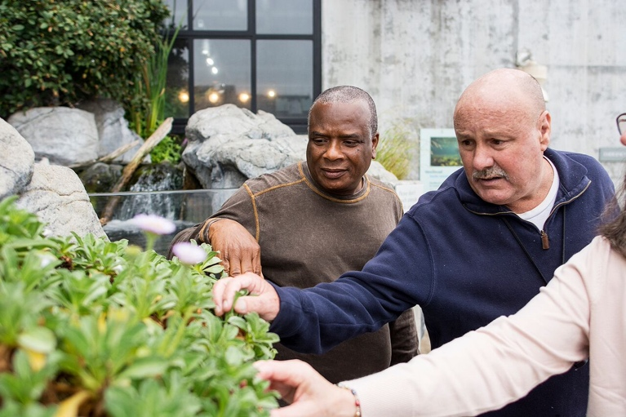
In August, a group of clients visited the Monterey Bay Aquarium and experienced exhibits through sound, touch, smell and limited vision.
Executive Director’s Article
Diana Trapani
The past year has been one of transition for BVIC. First with the hiring the new executive director. My first day was November 1, 2015 and the time has flown by. December saw the retirement of two long-time and beloved staff members, Jeannie Cordero and Rena Weaver. January brought changes to Dr. Wodecki’s scheduling in the Low Vision Clinic – we appreciate everyone’s patience and understanding with the schedule changes! In February two part-time orientation and mobility instructors, Roberta Williams and Jennifer Hirsch, joined the staff. March brought changes to the board with long time members transitioning off and new members joining the board.

In May we mourned the passing of Shirley Doolittle, who devoted her entire adult life to helping the blind and visually impaired, and was involved with BVIC from its inception. She is greatly missed. In July two board members retired and we welcomed Jenny Swad into the Low Vision Clinic. Dr. Moonset Yu retired in August and in September we welcomed Karen Levin as our new VRT. With the hiring of two new full-time staff we are just beginning to evaluate programming and determine what we can add to enhance services.

During all of these changes we were hard at work on a wide variety of initiatives funded by a special $150,000 grant from the Department of Rehabilitation. We have completed our new strategic plan and new annual fund development plan. Staff all have new computers, updated software, the building is now networked and we have a file server with daily cloud back-up of data. We purchased and have just about finished populating a donor database with as much history as we can. We are in the final stages of building a new case management software program to move (as much as possible) from paper to electronic record keeping. We are still working with a local marketing firm to create a new agency brochure, video, website and outreach plan. Soon, these will all be available for everyone to enjoy and share.

Throughout the year, staff have enjoyed professional development opportunities and we purchased a variety of no, low, and high-tech assistive devices for client education, trial, and/or use. The past year has been a flurry of activity, which will continue through December. By January 1, we should have completed everything with new systems in place and ready for use.

Keeping Afloat
May 1- Aug 31, 2016

$1-$499
Acosta, Margarite
Altrusa
Amazon Smile
Ames, David
Anable, Leonard
Anloff, Patricia
Anonymous
Arnot, Dene
Banks, Dave & Wendy
Bloch, R. Stephen
Brown, CW
Budlong, Edwin
Burja, Karen
Cardoza, Joan
Diaz, Herminia
electronic scrip rebate
Enea, Frank
e-Script
First Baptist Church
Fiske, Ernest
Fitton, Jean
Garcia, Aurelie
Gaver, Donald
Glazier, Carol
Gross, Sabreh
Gunderson, Gary & Tab
Hagey, Dolores
Heinz, Otto
Herschede, Lois
Holine, Virginia
Hough, Sonia
Jefferson, Veronica
Johansen, Holger "Bud"
Johnson, Marjorie
Kane, Steve
Keip, Nadia
Keleher, Norma
Keyser, Virginia
Kilty, Margaret
Kim, Grace
Ledin, Lisa
Levalley, Wallace
Loop, Mel
Lorenz, Roy
Lotz, Margaret & John
Masatani, Marilyn
Matsuyama, Mrs. Eva
McBee, Gloria
Mehl, Geneva
Mildred Hitchcock Huff Charitable Trust
Morgan, Elisha
Musavi, Sadri
Network for Good
Nohr, Maria
Oliver, Tom & Margaret
Ozenne, Helga
Perocchi, Nanci
Quaglia, Johnny
Rayne, Gerda
Reid, Dorothy
Rubin, Steven
Ruhl, Pauline
Ruiz, Kathleen
Salinas Host Lions
SaveMart
Schoenwisner, Mona
Stout, Candi
Thomas, Barbara
Thompson, Stella
Wright, Carla

$500-$999
Anonymous
Freedom Lions Club
Langstroth, Elizabeth
Mission Trail Lions Club of Carmel
Old Capitol Lions
Old Capitol Lions - Chariots for Charity
Thomas, Barbara

$1,000-$19,000
Anonymous
Holmlund, Helen
Irwin, Martin
Johnson, Bob
Foundation
Shaffi, Frances
Wilson, Julia

$20,000
Harden Foundation
Monterey Peninsula Foundation

In Honor of:
Arnold Green’s 100th B-day:
- McGarity, Lee

Dr. Andrew Wodecki:
- Sabih, David

Dr. Moonset Yu:
- Hagey, Dolores
- Williamson, Donald
- Wylie, Judith

In Memory of:
Shirley Doolittle:
- Dowden, Iris
- Jackson, Sonja
- Karanis, Joshua
- Marina Grange #518

Thank you to everyone for your support!
If we misspelled your name or missed listing your gift, we sincerely apologize and ask that you contact us.

Easy Ways to Help BVIC:
Make a cash donation! The BVIC is sustained by fundraisers, grants and gifts from the generosity of caring individuals. We also accept bequests, trusts and stock donations.

Facebook
Stay up to date on current news and events by following us on Facebook.

