BLINDFOLD

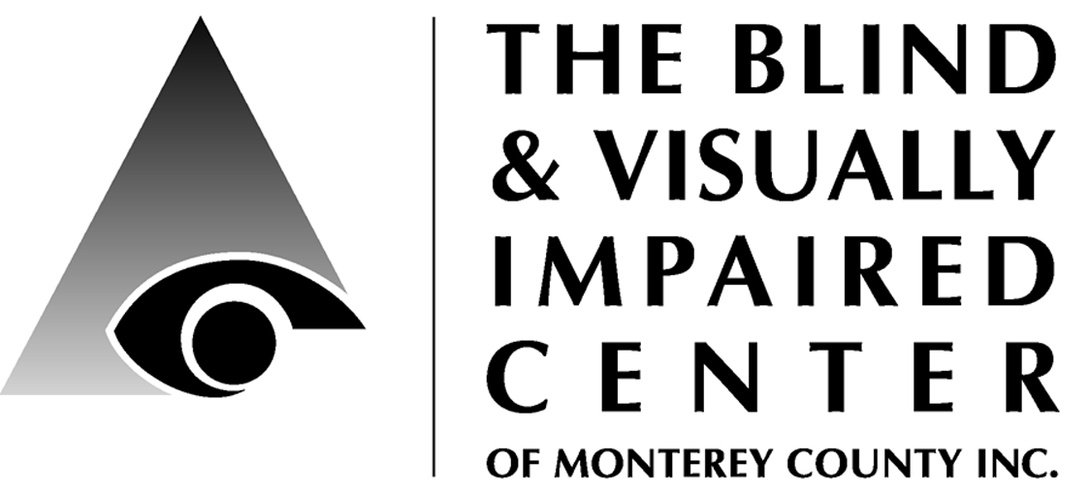

225 Laurel Avenue, Pacific Grove, CA 93950 (831) 649-3505 www.blindandlowvision.org

DECEMBER 2016

NEWS & ANNOUNCEMENTS

Annual Support Campaign
We are well on our way to reaching our $100,000 Annual Support Campaign goal! Many thanks to the board of directors who collectively have donated or pledged more
than $28,000 toward our goal.

If you have not yet sent your gift, you can
make your donation on-line through the MCGives 2016 campaign and it will be partially matched. For more info visit: https://www.montereycountygives.com

Pacific Grove Lions Club
The revitalized Pacific Grove Lions Club engages in activities which support the BVIC and other community groups. If you are interested in joining, please contact the Barbara Chamberlain at 831-251-6121 or email: barbarac@got.net.

Apple Store Discover Accessibility Classes
The BVIC is pleased to collaborate with the Apple Store, Del Monte Shopping Center to provide "Discover Accessibility" workshops on the accessibility features of the Mac and iPhone/iPad. To sign-up, visit their website: https://concierge.apple.com/workshops/R305/en_US/

Volunteer Opportunities
We are seeking volunteers to staff the front desk, answer the phone and greet visitors: 9:00am-1:30pm Tuesday, Thursday or Friday.

Tuesday Ceramic Art Class: Tuesday 11:00am – 2:00pm. Assist clients with ceramic art activities. Lunch is included!

Board of Director’s Openings
We have openings for board members and are accepting prospects with the following skills: human resources, accounting, insurance, fundraising, community connections, or non-profit management.

We are also looking for volunteers to join one of our committees:
- Finance
- Programs
- Fund Development
  - Events
  - Legacy Giving
  - Marketing & PR
  - Fundraising
Please send your interest to:
Diana Trapani @ The BVIC
225 Laurel Ave
Pacific Grove, CA 93950.

We’re looking forward to hearing from you!
Noticing that the handrails leading into the building were dirty, Ned offered to clean them on a bi-weekly basis. Thank you, Ned!

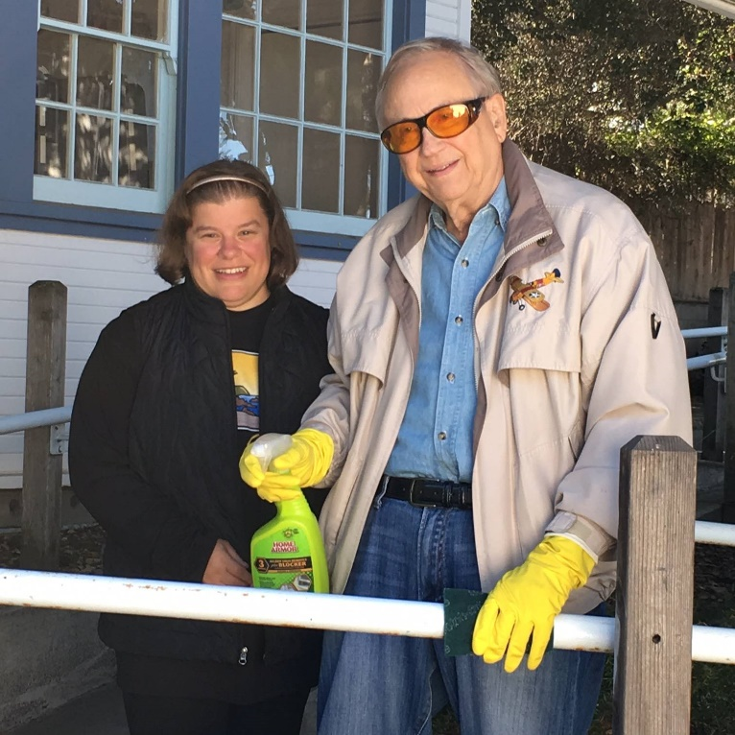
Karen Levin, VRT and Ned Budlong
Peer Support Group Benefits
Karen Levin, VRT
When people go through difficult periods in their lives, they may find a need to seek out individuals who share the same or similar condition. In a support group, people can talk with other folks who truly understand what they are experiencing and can share practical insights which can only come from firsthand experience.

Support groups are safe places where no judgements are made and the information shared is confidential. Members utilize active listening, do not talk over one another, and use I messages. Participants don’t try to fix one another, but instead share techniques and tips which have helped them in adjusting to their condition. Members share feelings, frustrations, successes and hope with others.

The group helps to provide reassurance, understanding and compassion for a person’s losses or gains. Members gain a sense of empowerment, self-confidence and control. They can learn to manage stress, depression and anxiety, and develop an understanding of what to expect from their condition. As members help and support one another, they develop a special bond within the group through sharing honest feelings.

Low Vision Peer Support Groups
Here at BVIC, we have three peer support groups for people living with low vision, two in English and one in Spanish.
English:
- 1st and 3rd Tuesday from 10:00-11:30 a.m. at 225 Laurel Ave, Pacific Grove
- 2nd and 4th Thursday from 9:00-10:30 a.m. at St. Ansgar’s Lutheran Church, 72 E. San Joaquin St., Salinas
Spanish:
- 1st and 3rd Thursday from 9:00-10:30 a.m. at St. Ansgar’s Lutheran Church

No reservations are required to attend our peer support groups – just show up and enjoy the benefits!

"The chief handicap of the blind is not blindness, but the attitude of seeing people towards them." - American Foundation for the Blind, Washington, DC, 1925

Kathy Henson: From Consumer to First Executive Director
by Jeannie Cordero
Kathleen Colvin Henson was a person who faced challenges with grace and believed in the services of the Blind & Visually Impaired Center of Monterey County.

Kathy was a true Monterey native whose local heritage dates to the 1700’s. She was diagnosed with juvenile diabetes in her childhood. As a young newlywed, she suddenly lost her vision, becoming totally blind because of the disease. Kidney failure made her dependent upon dialysis for the next five years until she was fortunate to be the recipient of a kidney transplant. She had regained her freedom, but her blindness limited her movement.

She reached out to the Blind & Visually Impaired Center (formerly known as the Blind Service Center). She received the skills and resources that helped her to adapt to her vision loss; emotional support, long cane training, braille and daily living skills which enabled her to fully live her life. The Center made such a positive difference in her life that she wanted to give back. She became a member in 1979, also becoming a volunteer and eventually serving as vice president of the BVIC board of directors.

Her involvement increased when she first began as a volunteer Executive Director in 1984. The orientation and mobility skills she received at the BVIC enabled her to attend Guide Dogs for the Blind where she was valedictorian of her class. Her dog guides, Brama and Bobby were an important part of her life and members of her family.

With Kathy’s leadership and dedication as Executive Director the Center flourished and community awareness improved. She was a charismatic spokesperson for the Center speaking at service clubs, businesses and agencies. During her tenure, services to clients increased, being provided throughout the expansive county. Kathy, Cindy Hazard and Mike Tomlin were the driving force of Monterey County’s premiere Low Vision Clinic in 1988.

She recognized the importance and need of raising funds at which she was adept. The annual Christmas Country Store fundraiser was her favorite as she enjoyed making crafts for the event. The special labels for her creations bore the appropriate name, Angels by Touch (labelled in braille).

Helping others was a natural part of Kathy’s life. She was big sister, for the Big Sister Program, a spokeswoman for Guide Dogs for the Blind, an active member of the Old Capitol Lion Club and served on the Pacific Grove Americans with Disabilities Act Committee. Kathy was fun loving and did not allow her blindness to hinder her. She met her husband, Randy Henson while learning to bowl.

Confronted with a multitude of health challenges throughout her life she lived fully with determination, compassion and joy. It was only when her health prevented her from serving in the capacity she wanted that she retired in 1998. Kathy died in 2001 at the age of 49. During her career with the BVIC she made a positive difference in countless people with her service. Kathy was a community leader whose enthusiasm and caring spirit touched the hearts of all she met.

In recognition of Kathy’s deep relationship with the BVIC, we are naming our legacy giving recognition group in her honor – Kathy Henson Legacy Society.

Launching Legacy Giving Program to Strengthen Our Future
Diana Trapani, Executive Director
Many BVIC supporters give money in appreciation of the services we provide. Now we have a formal way of making a donation which allows you to give through the simple stroke of your pen – a legacy gift, most often a bequest in your will or trust.
This gift will live on forever through our endowment, or as you designate. You can help others in the coming decades transcend the loss the sight with a legacy gift. By arranging a legacy gift you will ensure we continue to encourage and inspire the blind and visually impaired as independent members of our community.

The most common type of legacy gift is a bequest. When your attorney drafts your document, you simply ask that language be added including BVIC (See box on page 5). If you don’t yet have a will or living trust, we can provide you with a list of attorneys from which to choose. If you already have an estate plan, you can inexpensively update your documents to include BVIC through a codicil to your will or an amendment to your trust.

There are other types of legacy gifts that are even easier than a charitable bequest. You can make BVIC the beneficiary of your retirement plan. When you leave a retirement plan to your loved ones, income and estate taxes can eat up as much as 70% of the proceeds. However, when leaving your retirement plan to BVIC, all of the money will be used to bring our services to people with vision loss. As a nonprofit, we don’t pay taxes when receiving your retirement plan. All you do is fill out a designation form provided by your retirement plan administrator. The same thing can be done with an insurance policy, and many other types of assets, including real estate.

Some legacy gifts even allow you to make a gift and receive an income stream for the rest of your life. These are known as life income gifts. These are sometimes funded with highly appreciated assets such as securities or real estate. Making a life income gift will usually result in favorable treatment of capital gains tax to you. You also receive an income tax deduction for a portion of the gift. And there is no estate tax paid.

When you make a legacy gift the BVIC we will honor you by inviting you to join our Kathy Henson Legacy Society. Your name will be listed in our publications and we will recognize you at special legacy society events. Of course, you may choose to remain anonymous.

Questions? Interested? Please contact me for a confidential conversation: (831) 649-3505 x103 or diana@blindandlowvision.org.

Why do we choose to leave a legacy gift?
Ron & Ann Kihara
As a client, Board member, and volunteer for the Blind and Visually Impaired Center, I have come to know this organization intimately. Both my wife and I appreciate all the care and assistance we have received from the Center and their dedicated staff.
Sample bequest language: “I give, devise and bequeath to The Blind & Visually Impaired Center of Monterey County, Inc., a nonprofit corporation of the State of California, located at 225 Laurel Ave., Pacific Grove, CA 93950, (tax identification number 23-7221588), [amount, %, specific items, etc.] of my estate.”

Why do we choose to leave a legacy gift? It is because the Lions Clubs on our Central Coast have dedicated themselves to build, maintain, and continue a Center that has now endured for 45 years. As our population enjoys longer life, and better health care, the needs to meet the concerns of low vision and blind brothers and sisters becomes more and more challenging. The need for BVIC support and services will surely grow as our County population increases.

Some of you may know a family member who is losing their vision. The natural response for many is to give up some activities, like shopping, or walking, or going to movies, not to mention reading or using their computers. The BVIC has an amazing Clinic and trained staff to help give hope to all of us. With white cane training, I can now walk with confidence throughout my community, both day and night if necessary. Because of specialized computer software and staff training, I can type this very document, and manage my email. With advice and training, I can continue my cooking avocation, and safely manage my stove and microwave.

Perhaps best of all, the Center has a twice monthly meeting of a Support Group. Fifteen or twenty Center members come loyally to these meetings, where we share our challenges, our victories, and most importantly, give each other joy and hope. This group has been meeting now since 2013, and clients come for several reasons: "It is so good to hear that I am not the only one having these challenges;" "Our group has so much laughter, you raise my spirits;" "We give each other practical ideas, like how to manage our toothpaste.” And now we have two new Salinas support groups!

Our legacy gift is meant to contribute to the future of BVIC, and to provide real and practical assistance to families like our own. Please join us, your legacy gift will be very much needed and appreciated.

Supporting the needs of blind and low vision men and women in our community,
Ron and Ann Kihara

Low Vision Clinic
Jenny Swad, CLVT/COMS
This week finds me back from the 2016 statewide conference for the California Association of Orientation and Mobility Specialists, CAOMS, that took place in beautiful San Diego. I participated in many sessions, including:
- California School for the Blind
- BlindSquare Workshop
- Getting the most out of iPhone Accessibility Tools
- Yoga for the Visually Impaired
- Aira Technology

What I want to share with you is the information I learned about the Aira Visual Interpreter for the Blind. A visually impaired person uses wearable “smart” glasses that allows Aira telephone agents to see what the blind person sees in real time. Aira agents help users accomplish a wide range of daily tasks and activities – from recognizing faces, orienting to a room, and seeing items on a grocery store shelf.

The wearable smart glasses are free, but the user will need to pay a monthly rate based on the minutes you prefer per month. You will also need to download the Aira application using a Smartphone. Please note that the Aira Technology does not replace your great orientation and mobility skills that you would have learned with your Orientation and Mobility instructor.
If you are curious about the technology, look on-line (https://aira.io) and listen to their video. For more information on this product, fill out and send your contact information through their website. They will be happy to explain their services and go-over the monthly rates with you.

Should you decide to sign-up with them and are a cane user, please contact me and we can review your O&M skills and discuss any questions you may have about adding this new technology to your life.

In the next newsletter, I will make a list of recommended applications for your smartphone: books readers; identifying apps; magnifiers; GPS; and consumer education. See you next quarter!

Rehabilitation Assistant
Samantha Kelley
In the last newsletter, I introduced you to Peter White, BBC broadcast journalist and star of the series Blind Man Roams the Globe. Well, I can’t seem to get enough of Peter and indulged myself another one of his broadcasts, Blind Man’s Bete Noire.

In this four-part series, Peter vents his pet peeves about being blind, including his “allergy” to the countryside where he is surrounded by the stench of cow patties and the ominous wide open spaces in which he gets hopelessly lost. After complaining about the stinging nettles and the cacophony of the dull country chorus, his companion questioned whether these things perturbed him because he is blind or if it’s just because he’s British! He gave into the later.

Another episode touched on his annoyance with being introduced to other blind or visually impaired people just because they are both blind (yet have absolutely nothing else in common). He then discusses how he feels held back by sighted people who are constantly trying to get him to slow down, though he is perfectly capable of going at faster speeds, especially when he’s in a hurry! Finally, he touched on why he does not enjoy going on holiday and having to familiarize himself with a new place every day. It was in this episode someone told him about a company called Traveleyes and I wanted to briefly introduce it to you.

Founded by blind entrepreneur Amar Latif,
Traveleyes is the world’s first commercial tour operator providing independent travel for people who are blind or partially sighted. The beauty of traveling with Traveleyes is you can go it solo, as they pair you with a different sighted person each day so you don’t have to depend on family or friends to accompany you on your trip.

Sighted people are welcome to book with Traveleyes as well and, in fact, receive up to a 50% discount on trips in exchange for lending their eyes. Each holiday itinerary is carefully laid out to be a multi-sensory travel experience and includes places like Europe, Africa, Asia, Australia, and many more.

To learn about Traveleyes, please visit: http://traveleyes-international.com, or call BVIC and ask for Sam. To have a listen to Peter White’s pet peeves, visit BBC radio at: http://www.bbc.co.uk/programmes/b012h9m9

President’s Message: Year End Update
Ron Kihara
The year 2016 has brought many changes and challenges to the BVIC. We have always had a small but effective staff, so when three of our five staff retired, there was a huge challenge for Executive Director, Diana Trapani to continue Center operations.

We are excited about our new staff. Ms. Jenny Swad brings a wealth of experience and knowledge from her years with the Veteran’s Administration, Palo Alto. Jenny will continue the work begun by Dr. Moonset Yu in the Center clinic, as well as provide training in orientation and mobility.

Our latest hire, Ms. Karen Levin, also fills a long needed role as a teacher of Vision Rehabilitation and independent living skills. Clients are already benefiting from her experience and knowledge. Additionally, Karen is helping to lead two additional support groups in Salinas, one for English speakers, and a second group for Spanish speakers. Call the Center for meeting details if you are interested.

Our Executive Director, Diana Trapani, won an important grant from the State Department of Rehabilitation, which enabled the Center to update itself on several important fronts. We now have excellent and beautiful brochures which describe the activities of the Center. We will also provide a Spanish language version, important in Monterey County.

Soon, our new and improved website will be revealed. Our hopes are that this new website will be more accessible to our clientele, and more informative as well.

We entered our 2016 Annual Support Campaign with higher Board gifts and pledges than ever before. This reflects the Boards desire and determination to meet our growing challenges and increased costs. Please help us meet our campaign goal of raising $100,000. Don't be left out!

One of our highlights continues to be the ever-growing Support Group. Clients come because they learn that they are not the only ones facing the challenges of low vision. The challenges are not insurmountable, however, and we even manage to find humour in our situations. Together, we solve the problems of having to measure dish washer detergent, getting the right amount of toothpaste, and learning to handle paper money reliably. You are welcome to attend and learn our shared solutions.

Several of us have found an excellent corporate partner at the Apple Store. We attend iPhone and computer accessibility classes with James Krueger, who is especially gifted at teaching those of us who are blind or low vision. Now, I can more fully access the amazing capabilities of my iPhone, including some important applications. Did you know that your iPhone will give you walking directions to an address that you give to Siri? Come to a free Apple Store class and meet James.

I spoke recently with a person who said she had lost contact with many friends because she could no longer manage her email. This is not an unusual outcome for those who lose our vision. Our world starts to shrink. Fortunately for me and others, computer software can overcome our limitations, allowing us to email with abandon.

Feeling discouraged, or that low vision or blindness is taking away your independence? Come to the BVIC and learn about ways to restore your hope and independence.
Pacific Grove Monarch Lions Club
With support from Lions District 4C6 Officers and many Old Capital Lions members, the Pacific Grove Monarch Lions Club is reenergizing and rebuilding. The club’s mission is to support BVIC and other community events. Their first event was to support BVIC’s Christmas Store Auction and Health Screening Fair, held on Dec. 3rd. Thanks to their volunteer support the event was a big success!

If you are interested in joining the Monarch Lions, please attend the next meeting scheduled for Wed., Dec. 16 at 3:00 p.m. or email Barbara Chamberlain: carousel21@hotmail.com.

Chariots for Charity
Operated by the Old Capitol Lions Club, Chariots for Charity donations support the BVIC with cash donations from the sale of donated vehicles. For more information or to donate a vehicle, please contact Russ Hatch at 831-659-5360.

Holiday Shopping to Support BVIC
eScript on-line.
To sign-up simply register your phone number and select: eScrip Group ID – 500024165 Blind-Visually Impaired Ctr Monterey Co;. https://secure.escrip.com/signup/index.jsp,
eScript is good with hundreds of participating merchants. Be sure to check other stores where you shop and select BVIC to benefit from your holiday shopping!

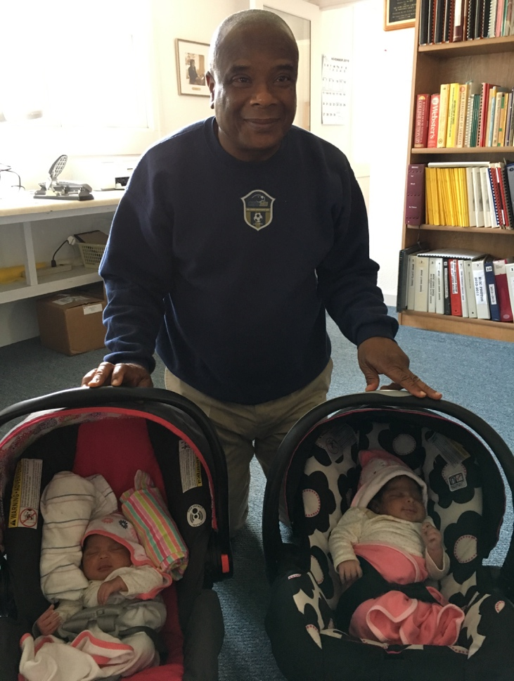
Congratulations to Francis Awitty and his family on the arrival of twin daughters! Bienvenida (on the left) means welcome and Porfina (on the right) means the end.
Goodshop
Select Blind and Visually Impaired Center – BVIC to benefit from your use of Goodshop. www.goodsearch.com. Don’t forget to download their mobile app!

Benefit-Mobile is a free app you download to your smart phone, purchase cards to your phone and use when you check out. Just use your app at check-out and BVIC gets a percentage of your purchase! Visit: www.benefit-mobile.com to sign-up, select The Blind & Visually Impaired Center of Monterey County as your beneficiary.
Each year, National Philanthropy Day acknowledges the tremendous contributions of philanthropy made by individuals in our community. On Friday, November 18th BVIC joined more than 400 people at Spanish Bay to honor Victoria Carns as our outstanding agency nominee.

For 21 continuous years, Victoria has graciously and generously served as our Tuesday Program volunteer extraordinaire! While coordinating weekly volunteers, ceramic classes, fieldtrips, birthday and holiday celebrations, Victoria expresses deep care and concern for our low vision clients who have become family to her.

Thank you for your generosity and love.

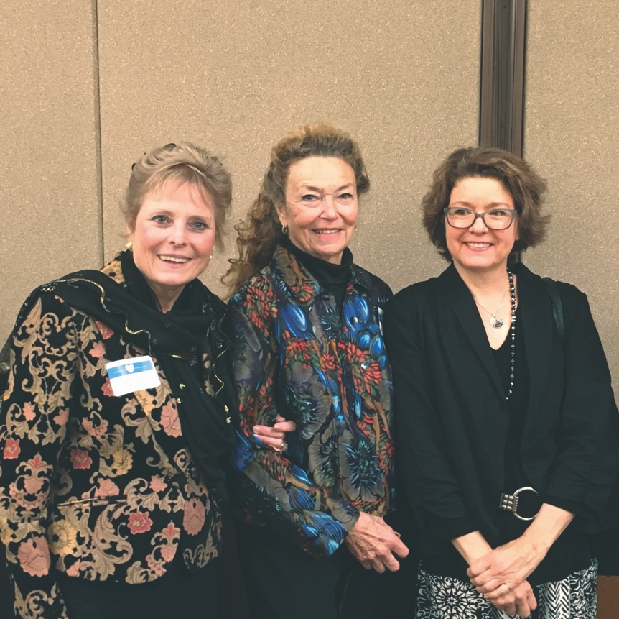

Victoria Carns, Joan Peffley, Michele Trinidad
Ceramic Art Class Volunteers

