BLINDFOLD

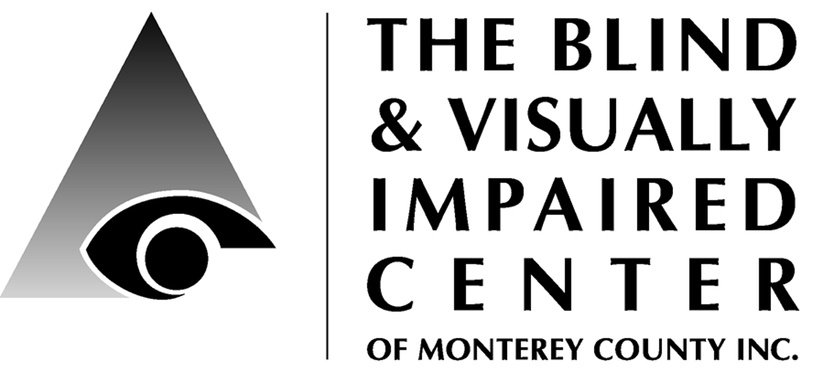

225 Laurel Avenue, Pacific Grove, CA 93950 (831) 649-3505 www.blindandlowvision.org

Fall 2017

NEWS & ANNOUNCEMENTS

Office Closure
The BVIC office will be closed Dec. 18, 2017 through Jan. 1, 2018 for inventory, report writing and other year-end activities. Staff will be working, so you can still call to schedule appointments, make referrals, etc.

Annual Meeting
The BVIC will hold its Annual Meeting on Thursday, February 8th at 1:00pm.

Community Outreach
Community Outreach is a growing service offered by the BVIC. We provide basic low vision training to other service providers, attend health fairs and/or present informational sessions at senior living communities and in the wider community.

If you would like us to visit your living community or attend your community event, please contact Sam at 649-3505.

New O&M Position
In keeping with our new strategic plan to evaluate program needs and add additional staff: The BVIC is pleased to announce we are looking for a full-time, dual certified, bi-lingual (English-Spanish) orientation and mobility specialist.

If you know someone who may be interested or if you are interested in applying for this position, please contact Diana by emailing
vision@blindandlowvision.org and she will send you the job description.

Peer Support Groups
Please contact Karen: 649-3505 x104.
English: Pacific Grove
- 1st & 3rd Tuesday from 10:00-11:30 a.m.

The Salinas support groups closed at the end of Nov. We are looking into starting a Spanish peer support group in south county in early 2018. Stay tuned for updates.

Braille Classes
For older adults who can no longer see well enough to read, braille can be a very useful skill and tool. Braille can be used in everyday communication, can help one locate the right elevator floor and office suites, and can be used to label many items, such as food, medicine, household objects and DVD's.

Our first group of students are learning, laughing and progressing well with their beginning braille lessons. If you are interested in learning braille, please call Karen 649-3505.

Facebook
Stay up to date on current news and events by following us on Facebook: https://www.facebook.com/BVICenter/

Website
Visit our website to learn more about our services and find helpful resources.
www.blindandlowvision.org

Volunteer Opportunities
Tuesday Ceramic Art Class Volunteers:
Tuesdays from 11:00am – 2:00pm with lunch or 12:00noon – 2:00pm without lunch.

Apple Store Discover Accessibility Classes
The BVIC is pleased to collaborate with the Apple Store, Del Monte Shopping Center to provide "Discover Accessibility" workshops on the accessibility features of the Mac and iPhone/iPad. To sign-up, visit their website: https://concierge.apple.com/workshops/R305/en_US/

Audio Library. Did you know that BVIC has a small but growing audio library of CD and MP3 books? Books, which are donated by clients and supporters, are located in our self-serve library which is maintained by volunteers. If you would like to help maintain the library, please contact Diana. It only takes about two hours/month and requires a laptop, basic excel to add new titles to our list, and alphabetizing the books on our shelf.

What is a Monocular?
Jenny Swad, CLVT/COMS
Chances are that you owned a binocular at some point in your life and that you used it for bird watching, at the opera or at sporting events. I owned one to watch the native birds in the cold Michigan snow from my backyard. Spotting a cardinal was always exciting. Unfortunately, when I moved, I thought I wouldn’t need it and it ended up in a garage sale. Big mistake. I find I could have used it to watch sporting events, take on hikes, and watch activity across the street from my house. Perhaps one reason I got rid of it was because it was big and heavy and that I didn’t use it every day. How does this relate to you?

As a person with low vision, we know that your near vision for reading requires special equipment and magnifiers to increase text size so that you can continue to read your mail or newspapers. Have you, as well, thought about your potential ability to see someone’s face across a room or table? How about your ability to do what you used to do; bird watch, neighborhood watch, see your friends at an event, and spot street signs and grocery store isle signs when walking. If you’ve adjusted to your sight loss, you know that “seeing” is not what it used to be, but you still may have potential to benefit from a distance device.

The distance device I am speaking of is called a monocular - not a binocular that we are all familiar with. With low vision, chances are you have a better eye or “best eye” and that is the eye that the Low Vision Optometrist along with the Low Vision Specialist is assessing and measuring to make as functional and useful to you as possible. In this case, you only need one lens to see through - hence the word monocular. The good news is that monoculars are much lighter and smaller than binoculars and a monocular with a neck cord can be worn around your neck so you can reach for it and use it quickly.

Do you remember having to choose a binocular? Did you buy the right kind? There are dozens of monoculars available by brand, price, and power, but be sure to see your Low Vision Optometrist if you are new to low vision devices, or call your Low Vision Specialist to help determine what power and type of monocular suits your particular vision condition. Monoculars can be more difficult to use if you have Macular Degeneration, but with training from your rehabilitation specialist, you can learn to spot, focus, scan, and even track objects.

If you don’t like the idea of having a piece of specialized equipment around your neck or in your bag, remember that those with better vision use instrumentation every day to see what they want to see – surgeons and jewelers!

Why is it important to use a Dexterity Board?
Karen Levin, VRT
People with visual impairments often need to learn new ways or skills to do everyday tasks. Dexterity boards can help you to learn and practice these new skills, which ultimately help maintain independence. These boards can help with basic tasks such as using a zipper and buttoning a shirt. But how about inserting new shoe laces in your shoes? How do you know if they are match up properly if you can’t see the holes? By working with me and dexterity boards, you can easily learn the skills to do these tasks.

Locking and unlocking doors can be very difficult when you can’t see the lock location or direction of your key. By practicing to feel the straight and cut side of the key and the slot where the key is inserted, you can begin to more easily and quickly lock and unlock your front door.

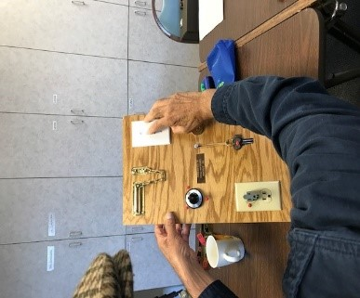

Mastering how to insert a plug into an electrical outlet is a very important safety skill to learn. Practicing to use various types of locks, latches, chains, keys and door knobs; knowing how to identify the temperature settings on your stove and safely adjust from on/off and low, medium or high also help with safety. What if you need to do some basic home maintenance? Dexterity boards can help you determine which type of screwdriver or nut you may need.

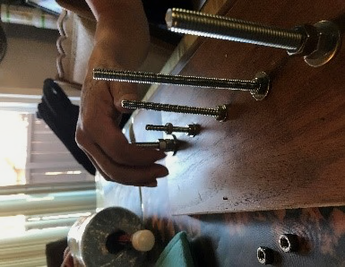
Thanks to a volunteer, we now have three dexterity boards at the Center. I will be happy to schedule an appointment with you and help you learn and practice everyday skills to ensure your safety and independence. Please call me at 831-649-3505 x104.

Willie Johnson’s Music
Dr. Katie Wendt, OD
There is no consensus on the cause of Blind Willie Johnson’s vision loss but when it comes to his music no one can argue—it’s out of this world! Willie Johnson was born in a small town in Texas around the late 19th century. Theories on the cause of his vision loss range from his step mother, in a state of rage, splashing lye water into his eyes (possibly meant for his father) to wearing the wrong prescription glasses (very unlikely).

Although he dreamed of becoming an ordained Baptist pastor, his vision loss caused him to focus on singing gospel-blues and playing the slide guitar as a street performer instead. Between 1927 and 1930 he became a well-known evangelist and musician. Columbia Records decided to take to the road with a mobile recording studio to capture the music of blues street musicians. Five recording sessions took place during this period.

Tragically, Willie Johnson’s home burned down around 1945 but Willie, having no place to go, slept in the drafty, damp house. He ended up contracting pneumonia and dying within the year.

Willie Johnson’s music lives on through his influence of more recent musicians. Artists such as Led Zepplin, Bob Dylan, Eric Clapton, Peter, Paul and Mary and Sinéad O’Connor and more have either recorded versions of his songs or reinterpreted his work.

When I said his music is “out of this world” I meant it, literally 12.8 billion miles from Earth. Currently Willie Johnson’s song “Dark Was the Night, Cold Was the Ground” is travelling through interstellar space aboard Voyager I. It’s on the Golden Record entitled “Sounds of the Earth”—just in case other life forms are out there and curious about us humans.

SUPPORTING BVIC
Year End Giving & MC GIVES
Ken Hunter, Board President

You can tell by the number of financial solicitations that it’s that time of year again. Your church, synagogue, or mosque may be requesting those end-of-the-year stewardship campaign appeals. The local news broadcaster is asking you to “share your holidays.” Military installations around the world would like you to buy “toys for tots.” And who can forget the bell-ringing Salvation Army volunteers posted at your neighborhood grocery or home-improvement store. Year-end donation requests also come from many non-profits, including the BVIC.

While it seems that we are pummeled with requests for donations during this Holiday period, it is important to remember that blindness never takes a holiday. Members of our community face the daily challenges of impaired vision whether it’s July or December. We shouldn’t forget the daily struggle that our visually-impaired family, friends and neighbors face. Those of us at the Blind and Visually Impaired Center of Monterey County (BVIC) work with these visually-challenged clients all year long. However, it is this time of year when we at the BVIC make our Holiday appeal to you, our generous donors.

There is a wonderful program sponsored by the Monterey County Weekly called MC GIVES. During this year-end time-period, donors can send a donation to MC Gives in the name of the BVIC. Your donation will be augmented by about a 13% match. In other words, if you donated $1,000 to the BVIC, MC Gives would add approximately $130 to the donation.

You really can’t beat a 13% return on your investment to the BVIC! As of Nov. 20th, we have already received a total of $10,535 in donations. The Monterey Old Capital Lions made a $7,500 challenge gift and Dr. & Mrs. Martin Lipp made a $1,000 challenge gift. You can help us reach meet their combined $8,500 challenge and more by making your donation online at:
https://www.montereycountygives.com/nonprofit/blind-visually-impaired-center/ .

We appreciate your generosity at this time and wish you and your family all the best during this Holiday season.

Your Vital Support
BVIC’s 2017 annual operating budget is about $572,000. This is about $11,000 each week to cover expenses including staffing and payroll costs, program equipment, IT, overhead, and other costs such as this newsletter.

Your support is vital to ensuring we continue to offer our free low vision, vision rehab, and
orientation & mobility services, low cost low vision clinic, free materials, and outreach services.

Please consider how you would like to support the center and send your gift to cover:
$11,000 for one week of costs
$ 5,500 for half-a-week of costs
$ 2,200 for one day of costs
$ 1,100 for half-a-day of costs
$ 275 for one hour of costs
$ 138 for half-an-hour of costs

The clients thank you for your generosity!

"The BVIC gave me back my independence. I will be forever grateful!"

Country Store Auction
Thank you to everyone who donated to our annual fundraising event, Country Store Auction. Held on October 28th, the event was fun and festive with homemade yummies and goods, barbershop quartet singing, food and fun!

CSA Auction Donors
A Taste of Monterey
Aliotti's Victorian Corner Restaurant
American Burger
Anonymous
Back Porch Fabric
Bargetto Winery
Bistro Moulin
Bookmark
Cafe Fina
California Pizza Kitchen
Cannery Rogues Barbershop Quartet
Carmel Bach Festival
Dick, John & Jackie
Domenico's on the Wharf
Embler, Sheryl
Events by Classic
FishWife
Franke, Rick & Kit
Freedom Lions Club
Gardner, Tom & Sylvia
Hahn Family Wines
Hawaiian Bodywork and Massage by Jerilyn Burch
Jackson, William & Sonja
Johnson, Bob
Katy's Place
Klaumann, Clyde & Pam
Korper, Tom & Marta
La Mia Cucinal Restorante
Lalla Grill
Linda's Hair Styles
Lions San Jose Host East Valley Lions Club
Loop, Mel
Lula's Chocolates
Monterey Bay Aquarium
Monterey Institute of Touch
Monterey Marriott
Monterey Sports Center
Monterey Symphony
Mority, Regina
Old Fisherman's Grotto
Pacific Repertory Theatre
Pacific Thai Cuisine
Patisserie Bechler
Pavel's Backerei
Peppers Mexicali Cafe
PF Chang
Pizza My Heart
Portola Hotel & Spa at Monterey Bay
Redstone, Charlotte
Rekedal, Jane
Rosine's Restaurant
Salinas Valley Fair
San Franscisco Zoo & Gardens
Sardine Factory
Schoenwisner, Mona
Spencers Stationery
Stewart, Robert & Becky
Taste Cafe & Bistro
TJ Plew and Kids
Tragethon, Jan
Trapani, Diana & John
Valenti, Jack & Donna
Winchester Mystery House
Winning Wheels Bicycle Shop

We extend our heartfelt thanks for your support!
Donors: July 1 – Sept. 30:
A&E Low Vision Products (Enhanced Vision)
Almaden Super Lions Charitable Foundation
Amazon Smile
Anonymous
Bramers, William
Britton, Robert
Budlong, Ned & Barberena, Celia
Burja, Karen
Butterfly House
Cannon, Thomas
Carmel Rotary Fund of the CFMCO
Chariots for Charity: Old Capitol Lions
David, Beverly
Diaz, Herminia
Errea, Miguel & Dorothy
Escript
Fernando, Rachel
Gross, Sabreh
Gunderson, Gary & Tab
Harrison, James & Carol
Jackson, Sonja
Johansen, Holger "Bud"
Keyser, Virginia
Lewis, Roswitha
Loop, Mel
Lorenz, Roy
Meyers, Alice
Mission Trail Lions Club of Carmel
Myszak, Martha
Network for Good
Okamura, Joey
Pacific Grove Women's Golf Club
Parsons, Julie
Reid, Dorothy
San Jose Japantown Lions Foundation
Schoenwisner, Beatrice
Schoenwisner, Mona
Schure, Cam
Stanley, Margaret
Stewart, Rebecca
Thomas, Barbara
Thompson, Stella
Tobi.com
Yellow Brick Road Benefit Shop
Young, G E

Bequest:
- The Agnes Fraser Gump 2007 Trust ($250,000)
- The Patricia Smith Ramsey Trust ($37,500)
In Honor of:
All Blind & AMD People
- Thomas, Donald
Grace Emerson
- Sabih, David
Mona Schoenwisner’s 80th Birthday
- A&R Plumbing
- Klein, Patricia & Ralph
- McGowan, Anne
- Rianda, Beverly
- Silguero, Marty & Judy
- Aeschliman, Greg & Robin
- Gammon, Blair & Laura
- Ingram, Candace
- Leadingham, David & Marsha
- Schaffer, Donna
- Seltzer, Ron & ArvaDell
- Harris, Leasa
- Martin, Elaina & Frank
- Tendler-Valencia, Cath
- Klaumann, Clyde
- Rosen, Lee & Shirley
- Plastini, Marian & John

Russ & Jo-Ann Hatch 50th Anniversary
- Klaumann, Clyde & Pam
- Rosen, Lee & Shirley
- Plastini, Marian & John

In Memory of:
Stella Thompson
- Frank Thompson

If we missed listing you or misspelled your name we apologize and ask that you please contact the office. Thank you.

Endowment Fund
Did you know that over the years, many BVIC clients and donors have left a bequest to the center? Their gifts have been used to establish a modest endowment fund. The Board uses earnings from the fund to expand programming, purchase equipment or supplement the annual operating budget. However, they never invade the principle, and strive to leave earnings in the fund to build the base for future needs.

By including the BVIC in your estate plans, you can help build the endowment base to ensure a strong future for the BVIC and quality services for our next 46 years of service to the visually impaired community. For more information, please contact Diana Trapani at the BVIC office: (831) 649-3505 or email vision@blindandlowvision.org.
Kathy Henson Legacy Society
By including BVIC in your estate plans, you can help others in the coming decades transcend the loss the sight with a legacy gift.

Sample bequest language: “I give, devise and bequeath to The Blind & Visually Impaired Center of Monterey County, Inc., a nonprofit corporation of the State of California, located at 225 Laurel Ave., Pacific Grove, CA 93950, (tax identification number 23-7221588), [amount, %, specific items, etc.] of my estate.”

Chariots for Charity
Operated by the Monterey Old Capitol Lions Club, Chariots for Charity vehicle donations support the BVIC with cash donations from the sale of donated vehicles. Operated since 1985, the Chariots program has raised more than $300,000 to support BVIC!

For more information or to donate a vehicle, please contact Russ Hatch at 831-659-5360.

Holiday Shopping to Support BVIC
Please use any of these shopping sources to do your holiday shopping and support services for the visually impaired at the same time!

eScript on-line.
To sign-up simply register your phone number and select: eScrip Group ID – 500024165 Blind-Visually Impaired Ctr Monterey Co;. https://secure.escrip.com/signup/index.jsp,
eScript is good with hundreds of participating merchants.

Goodshop & Goodsearch
Select Blind and Visually Impaired Center – BVIC to benefit from your use of Goodshop. www.goodsearch.com. Don’t forget to download their mobile app!

Benefit-Mobile is a free app you download to your smart phone, purchase cards to your phone and use when you check out. Visit: www.benefit-mobile.com to sign-up, select The Blind & Visually Impaired Center of Monterey County as your beneficiary.

Thank you and Happy Holidays!

