BLINDFOLD

225 Laurel Avenue, Pacific Grove, CA 93950 (831) 649-3505 www.blindandlowvision.org

WINTER 2017

NEWS & ANNOUNCEMENTS

Annual Meeting: Feb. 16 @ 1:00pm
We will hold our membership Annual Meeting on Thursday, February 16 at 1:00pm in the back building. If you are planning to attend, please RSVP by calling Diana at 649-3505.

Low Vision Clinic
Katherine Wendt, OD
BVIC is pleased to welcome Dr. Katie Wendt, OD to our Low Vision Clinic. Dr. Katie Wendt is originally from San Jose, California. Her educational background includes a Bachelor of Arts in Physiology and Cell Biology from the University of California at Santa Barbara, Bachelor of Science and Doctorate degrees in Optometry from the University of California at Berkeley, and a Master of Business Administration from the University of Washington.

Dr. Wendt comes to us with a wide range of Optometric experience. She has practiced in a military hospital and clinic, health maintenance organizations, and private practices in five different states due to numerous moves with her career military husband. Together Dr. Wendt and her husband have experienced the military way

of life for over 30 years. Dr. Wendt has volunteered with organizations such as the American Red Cross, Military Spouses’ Clubs, the Army Family Action Plan program, Protestant Women of the Chapel at the local and regional levels, several Army Family Readiness Groups, “Help the World See,” and with her local church.

She and her husband have an adult daughter and a high school-aged son. Dr. Wendt’s hobbies include traveling, machine quilting, and playing the flute with the Del Monte Brass Band.

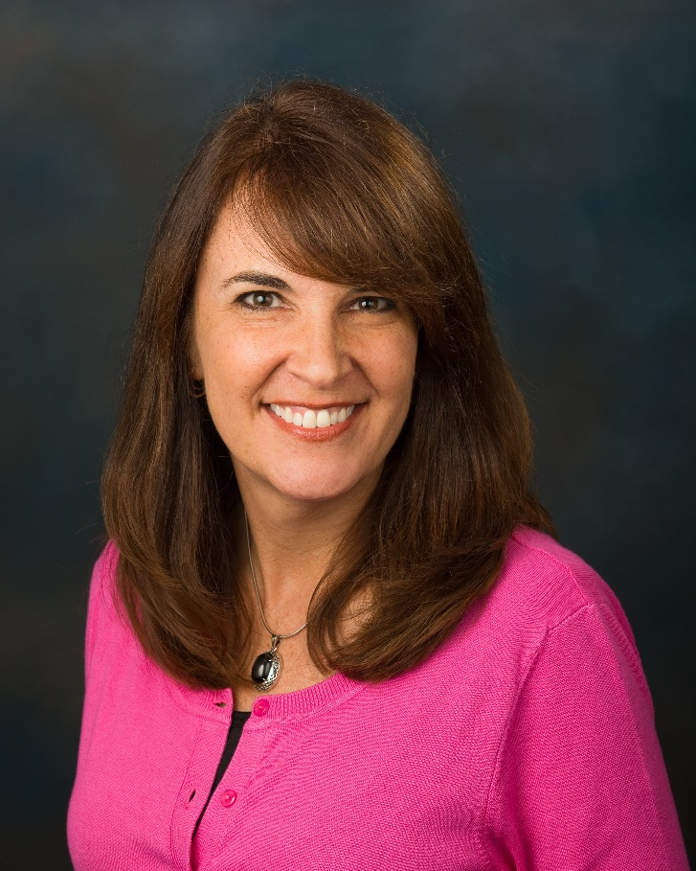
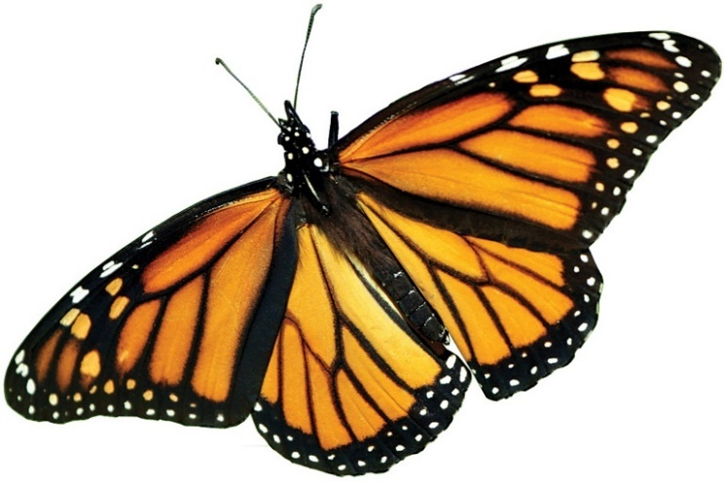
Dr. Wendt will begin seeing clinic clients in February. Please call Sam at 649-3505 x101 to schedule an appointment.

Volunteer Opportunities
We are seeking volunteers to staff the front desk, answer the phone and greet visitors: 9:00am-1:30pm Tuesday, Thursday or Friday.

Tuesday Ceramic Art Class:
Tuesdays from 11:00am – 2:00pm with lunch or 12:00noon – 2:00pm.

Peer Support Groups:
English:
- 1st & 3rd Tuesday from 10:00-11:30 a.m. at 225 Laurel Ave, Pacific Grove
- 2nd & 4th Thursday from 9:00-10:30 a.m. at St. Ansgar’s Lutheran Church, 72 E. San Joaquin St., Salinas
Spanish:
- 1st & 3rd Thursday from 9:00-10:30 a.m. at St. Ansgar’s Lutheran Church

No reservations are required to attend our peer support groups – just show up and enjoy the benefits!

Pacific Grove Lions Club: “The Monarchs”
The revitalized Pacific Grove Lions Club has named itself “The Monarchs” after the
beautiful butterflies who cluster on local pine, cypress and eucalyptus trees.
Our next community outreach event will be to provide information about vision loss at Good Old Days, April 8 & 9 in Pacific Grove.
We are currently meeting on the second Wednesday of each month at 3pm in BVIC’s back build. If you are interested in learning more about the Lions and/or joining our club, please attend our meeting or call Barbara Chamberlain at 831-251-6121. You don’t have to live in PG to join the PG Lions!

Board of Director’s Openings
We have openings for board members and are accepting prospects with the following skills: human resources, accounting, insurance, fundraising, community connections, or non-profit management.

We are also looking for volunteers to join one of our committees:
- Finance
- Programs
- Fund Development
  - Events
  - Legacy Giving
  - Outreach, Marketing & PR
  - Fundraising
Please send your interest to:
Diana@blindandlowvision.org

We’re looking forward to hearing from you!

Apple Store to the Rescue
Ron Kihara, Board President
Two years ago, I decided to purchase an iPhone, knowing that "Siri" would help me to phone my contacts. I believed this popular device would take a certain amount of stress out of my life.

I soon discovered that the iPhone was so complicated and advanced that I was not able to master enough skills to use the many options and applications that come with the standard iPhone.

A few months ago, a staff member at the Apple Store, James Krueger, began leading "accessibility" classes for the blind and low vision users of Apple products, including Macs, iPads, and iPhones.

For example, I have now mastered the task of entering new contacts onto my phone, something I had needed assistance from a sighted person to do. Just this capability gives me control and independence I had not previously known.

My low vision friends and I have discovered that we have increased difficulty in navigating around town. Thanks to Mr. Krueger's instruction, I am now able to ask Siri for walking directions to a particular address, and Siri will tell me how to get to my destination on foot. This is very similar to the GPS instructions for auto drivers, but very useful for those of us who want to maintain our independence in and about our communities.

The Apple iPhones have a feature called "Voice Over" that helps the user to orient him/herself to the phone screen. With practice and increased familiarity, I now find that I have almost the full capability of a sighted person. I listen to news articles, listen as Voice Over reads my email, and have full access to other useful applications.

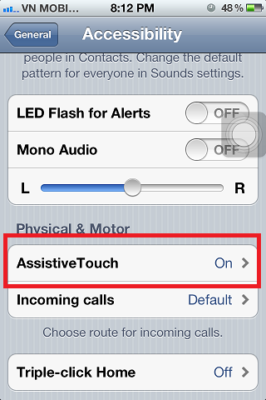

If you are low vision, and considering the purchase of a "Smart Phone," please give consideration to an iPhone. The Apple Store Accessibility Classes are provided at no charge to the clients, an important benefit.

I admit that the Apple Store has made me a happy customer, but I am writing this article not to promote their product, but to inform clients of BVIC that this iPhone has added immensely to my ability to remain independent, so important to all of us.

Apple Store Discover Accessibility Classes
The BVIC is pleased to collaborate with the Apple Store, Del Monte Shopping Center to provide "Discover Accessibility" workshops on the accessibility features of the Mac and iPhone/iPad. To sign-up, visit their website: https://concierge.apple.com/workshops/R305/en_US/

Executive Director
Diana Trapani
We are pleased to announce that BVIC was awarded a $19,200 grant from the Disability Communications Fund (DCF). DCF supports technology and programs that serve the communication needs of Californians with disabilities. Our grant funds will be used to educate staff about various assistive technologies which will assist our clients with communication.

Staff will join a number of professional organizations and will attend a variety of conferences, workshops and other training opportunities related to no-, low-, and mid-level assistive technologies this year. Additionally, we will share what we learn with clients and other service providers, as well as write articles for the newsletter and facebook. We will purchase samples of products we think will be helpful and demonstrate them to clients.
Sam Kelley and Jenny Swad just returned from the Assistive Technology Industry Association conference, which was held in Florida. In late February, Karen Levin will attend the CSUN Assistive Technology conference in San Diego. In early March, I will attend the American Federation for the Blind Leadership Conference. Jenny and Karen will both attend the AER International Orientation & Mobility Conference this July.

Be sure to read our next newsletters for more information about what we learn and how assistive technologies may help you!

Vision Rehabilitation Benefits
Karen Levin, VRT
Vision Rehabilitation Therapists (VRT) teach adaptive independent living skills, enabling adults who are blind or have low-vision to perform a wide range of essential daily living activities using devices or modifying a task and communication skills for coping with their vision loss. Some adaptive skills include: Braille, computers, handwriting, listening and recording technology, low-vision technology, mathematical calculation and keyboarding. Instruction in daily living skills includes food preparation, labeling items, money management, marking appliances, personal management, home management, home mechanics, leisure and recreation activities, and orientation and movement in familiar indoor environments.
Services are primarily provided in two major settings: rehabilitation centers designed to serve groups of people and in people's homes. Therapists work with individual clients or small groups.
When performing an in-house assessment, I conduct an in-depth interview which help me determine the present needs and skill levels of the client. Once I have identified potential problem areas, I work with the client to problem solve and create goals. We then work together toward achieving these goals and ensuring you have the skills and tools to safely and confidently engage in a variety of activities.
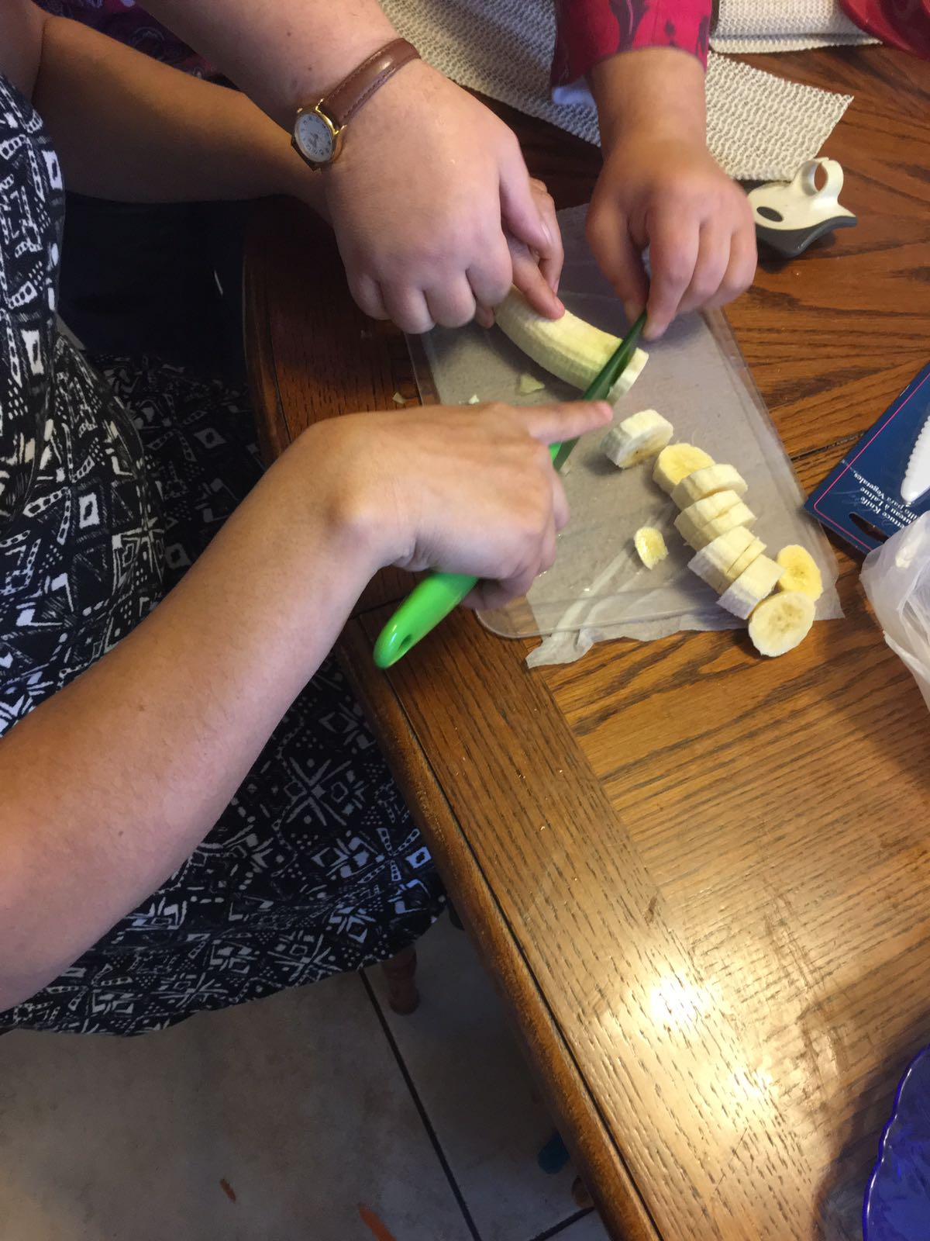
My goal is to meet with each of BVIC’s clients, conduct an interview, and have us determine how I can best assist you in living with vision loss. Please call me at 649-3505 x104 to schedule an appointment! I am looking forward to meeting and working with more of you in 2017.
Low Vision Clinic
Jenny Swad, CLVT/COMS
As a follow-up to my last article, here is a list of various applications for your computer and/or smartphone. These suggestions come from experts in the technology field who work solely with clients looking for high-tech solutions for everyday tasks. Some are free and some cost money.

If you have further questions about these applications, please call me and we can determine the benefit to you or find alternative applications and even low tech ideas for accomplishing the task you have in mind.

- MONEY IDENTIFICATION: NantMobile Money Reader by IPPLEX (Free); LookTel Money Reader by IPPLEX ($9,99); EyeNote by Bureau of Engraving and Printing (Free)
- COLOR IDENTIFICATION: ColorDetect by sunset software Ltd, $1.99; Color ID by GreenCar Studios, Free; Color Blind Pal by Vincent Fiorintini, Free
- OBJECT IDENTIFICATION: TapTapSee by CamFind Inc, Free; LookTel Recognizer by IPPLEX, $9.99; Be My Eyes by Be My Eyes Inc, Free
- OCR: TEXT-TO-SPEECH: Knfb Reader by Sensotech, $99; Text Grabber by ABBY, $4.99; Prizmo by Creaceed SPRL, $9.99
- BOOK READERS: BARD Mobile by Library of Congress, Free; NFB Newsline by National Federation of the Blind, Free; Read2Go by Benetch, $19.99; Kindle by AMZN Mobile LLC, Free; Audible by Audible Inc, Free
- OTHER IDENTIFYING APPS: Light Detector by EveryWare Technologies, $0.99; Digit-Eyes by Digital Miracles LLC, $9.99; Go Find Marco Phone Finder by Sir Conrad Pty Ltd, Free
- MAGNIFERS: Magnifying Glass with Light; by Falcon in Motion, Free; BigMagnify Free by Dave Cheng, Free; iMagnifier + - Magnifying Glass by Scaleitapp Ltd, $1.99
- GPS: BlindSquare by MIPsoft, $39.99; Seeing Eye GPS, by Sendero Group, Free; Around Me by Flying Code Ltd, Free; Ariadne, Giovanni Ciaffoni, $5.99; Google Maps, Free; OverTHERE, Dmitrijs Prohorenkovs, Free
- CONSUMER EDUCATION: Access World by American Foundation of the Blind, Free; ViA by Braille Institute, Free; VisionSim by Evil Genius Technologies, Free
- RESOURCES
- www.zoomtext.com/download-zoomtext-free-trial/
- https://yourdolphin.com/product/try?id=5
- www.freedomscientific.com/downloads/jaws

Rehabilitation Assistant
Samantha Kelley
This week, Jenny and I had the opportunity to attend the ATIA (Assistive Technology Industry Association) conference in Orlando, Florida. What an experience! (And I’m not just saying that because I am writing this from a lounge chair under a giant waterfall with a piña colada at my side.) People from all over the country were here to share their experiences and learn more about what’s being offered in the field of assistive technology. I attended many classes and demos and got to know more about the world of scanning pens, high tech camera-glasses, assistive options for iOS on the iPhone, and much more.

One item that really stood out to me is the OrCam - an intuitive wearable device with a smart camera and a goal in mind of promoting quality of life and giving independence to people with all levels of vision loss.
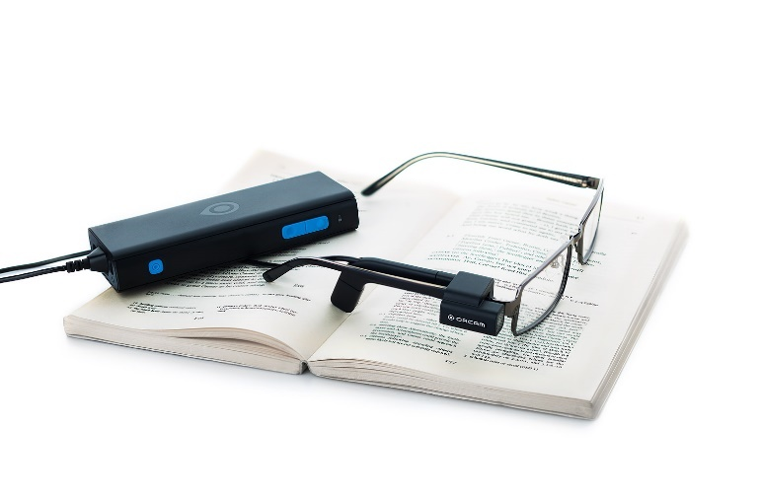
The smart camera is mounted on the user’s glasses. It interprets - in real time - what the user is seeing; it recognizes text, products and faces that have been programed in ahead of time, hand motions, and much more. It then conveys that information to the user via an ear piece.

After the presentation, I went over to the OrCam booth to ask some questions and they gave me a one-on-one demo. The representative wearing the Orcam on his glasses looked at me, pressed a button on his remote, and spoke aloud, “This is Sam.” The OrCam then stored the information and when he looked at me again, his earpiece told him, “This is Sam.” The same concept goes for common household items, kitchen cupboard items, etc. Once they are programmed in (which takes less than thirty seconds), the camera will recognize them immediately.

This is also an incredibly easy way to read the newspaper, read your email, recognize money, and tell the time. One of the most exciting things they are currently working on is giving the camera the ability to recognize bar codes. The best thing is that they have fifty engineers working on this single product, so they are constantly innovating and improving.

If you are interested in learning more about what the OrCam can do and its pricing, please contact Sam. We do not currently have a demo at BVIC, but I have connected with their representatives and hope to see about acquiring one.

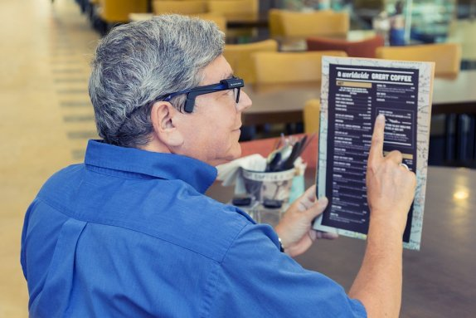
SUPPORTING BVIC
Shopping to Support BVIC
eScript on-line.
To sign-up simply register your phone number and select: eScrip Group ID – 500024165 Blind-Visually Impaired Ctr Monterey Co;. https://secure.escrip.com/signup/index.jsp,
eScript is good with hundreds of participating merchants.

Goodshop
Select Blind and Visually Impaired Center – BVIC to benefit from your use of Goodshop. www.goodsearch.com. Don’t forget to download their mobile app!

Benefit-Mobile is a free app you download to your smart phone, purchase cards to your phone and use when you check out. Visit: www.benefit-mobile.com to sign-up, select The Blind & Visually Impaired Center of Monterey County as your beneficiary.

Chariots for Charity
Operated by the Old Capitol Lions Club, Chariots for Charity vehicle donations support the BVIC with cash donations from the sale of donated vehicles. For more information or to donate a vehicle, please contact Russ Hatch at 831-659-5360.

Facebook
Stay up to date on current news and events by following us on Facebook: https://www.facebook.com/BVICenter/

Kathy Henson Legacy Society
By including BVIC in your estate plans, you can help others in the coming decades transcend the loss the sight with a legacy gift.

Sample bequest language: “I give, devise and bequeath to The Blind & Visually Impaired Center of Monterey County, Inc., a nonprofit corporation of the State of California, located at 225 Laurel Ave., Pacific Grove, CA 93950, (tax identification number 23-7221588), [amount, %, specific items, etc.] of my estate.”

The BVIC is sustained by fundraisers, grants and gifts from the generosity of caring individuals. Thank you for your generous support!

Keeping Afloat
Sept. 1 – Dec. 31, 2016.

$1 - $999
Anonymous
Altrusa International of Monterey Peninsula
Amazon Smile
Amundsen, Elizabeth
Anloff, Patricia
Banks, Dave & Wendy
Barnhart, Lucille
Bartels, Franzel
Bennett, Barbara
Bloch, R. Stephen
Britton, Robert
Brott, Dale
Brown, Charles
Brown, Elizabeth Plaxton
Bucquet, Barbara
Budlong, Edwin & Barberena, Celia
Bugarin, Eva
Cannery Row Company
Cardoza, Joan
Carmel Women’s Club
Carns, Victoria
Chavez, Agueda
Chiappe, Elio
Chow Hoon, Pauline
Cocker, Enid
Conlow, M Robin
Covarrubias, Fernando
Craft, Mr. & Mrs. Nick
Craig, Geoff & Carolyn
Cruz, Celeste
Cutino, Bert
D'Arrigo, John
David, Beverly
Davis, Paul
Diaz, Herminia
Dominguez
Doolittle, William & Nancy
Dority Roofing & Solar
Dunn, Virginia & Richard
e-Scrip
Farrant, Catherine
Fehl, Cecile
First Presbyterian Church
Fiske, Ernest
Festival of Trees: North Fremont Business District
Forever Friends
Frasca, Joyce
Gehringer, Helen
Goodshop
Green, Arnold
Gryp, Janice
Gunderson, Gary
Haas, Doris
Holine, Virginia
Hough, Sonia
Hurd, Sylvia
Hutchins, Charles
Jackson, Sonja
Johnson, Michaele
Johnstone, Elizabeth
Kadiev, George & Nina
Kane, Steve
Keland, Harold
Keleher, Norma
Keyser, Virginia
Kihara, Ron
Legard, Robert
Livingston, Barbara Timmins
Loop, Mel
Lotz, Margaret & John
Lundy, Jane
Lyon, Willis
Maraccini, Diane
Mehl, Geneva
Merrell, Esther
Miguel, Heide
Monterey Bay Analytical Services
Network for Good
Nicolai, Adolph
Nielsen, Gary & Deborah
O'Connor, Paula
Old Capitol Lions
Pacific Grove Hardware
Parsons, Julie
Peel, Alan
Pepperdene, Rose
Pesce, Mr. & Mrs. Thomas
Rayne, Gerda
Ruhl, Pauline
Ruiz, Kathleen
Schoenwisner, Mona
Schure, Cam
Shaffi, Frances
Sherman, Mary
Shimizu, Ronald
Shipley, Margaret
Silverman, Marv
Springer, Elizabeth
Stafford, Doug & Karen
Suarez, Jorge
Suter, Jean
Teixeira, Sylvia
Thompson, Stella
Tucker, Philip
VanArsdol, Maurice
Vaughn, Marie
Wagner, Bruce
Walters, Lila
Weismann, Richard & Joyce
Wills, Judy
Wilson, Ardith
Wilson, Janet
Young, G E
Ziegenbein, Constance

$1,000 - $2,499
Brown, Rosemary
Colburn, Mary
Monterey Peninsula Host Lions

$2,500 - $4,999
Hatch, Russ & Jo-Ann
Kihara, Ron & Ann
Old Capitol Lions

$5,000 - $9,999
Flicker, Perry

$10,000 - $19,999
Community Foundation for Monterey County

$20,000+
Harden Foundation
Radunich, Margaret Anderson (estate of)

In Honor of:
“all you wonderful people at BVIC”
- Brown, Elizabeth
Shahin Anable:
- Anable, Leonard
Victoria Carnes:
- Anonymous
Beverly David:
- Palmer Earp, Dorothy
Doris Hale:
- Hale, John
Sonja Jackson:
- Linda’s Beauty Salon
Bob Johnson:
- Anable, Leonard
- Rhodes, Dan & Robbie
- Yost, David and Terri
Esther Merrell:
- Maroot, Janice
Mona Schoenwisner:
- Craig, Geoff & Carolyn
- Geary, Patti
- Gamble, Barbara

In Memory of:
Shirley Doolittle:
- Ansberry, Janelle
- Blake, Joan
- Catania, Lynn
- David, Beverly
- Ferrante, Barbara
- Fishbeck, Karen
- Gruwell, Sherry
- Hamilton, Armetta
- Hawkins, Larry
- Johnson, Jackie
- Lincoln, Sara & Rosie
- Malohn, Mary Lou
- Marquez, Janis
- McRae, Debi
- Merrilees, Debbie
- Morgan, Arcola
- Quamen, Ann
- Trindad, Bernie
Michael Dumller:
- Dumller, Sue
Ted & Marie Fehring:
- Holbrook, JoAnn Fehring
Kathy Henson:
- Colvin, Gloria
Miyake, Shig, Aya & Terry Kihara:
- Nagata, George & Joanne
Marge Ross:
- Moe, Alice
Mom’s Birthday:
- Dalkey, Sharon Lee
Irma Ruckman:
- Schwoerke, Karin
Richard Takashi:
- Nagata, George & Joanne

Thank you to everyone for your support!
If we misspelled your name or missed listing your gift, we sincerely apologize and ask that you contact us.

Many thanks to everyone who made our Christmas Store Auction & Health Screening Fair a big success!

Adventures by the Sea
Altrusa International of Monterey Peninsula
Back Porch Fabric
Bodywork & Therapeutic Massage
Cafe Fina
California Pizza Kitchen
Carmel Chamber of Commerce
Carmel Host Lions Club
Chatterbaux Children's Shoppe
Domenico's on the Wharf
Dority Roofing & Solar
El Estero Car Wash
Events by Classic Catering
Fandango Restaurant
Fish Hopper
Hattori Vision
Holly's Lighthouse Cafe
il Vecchio
Jeffrey's Grill & Catering
Katy's Place
Monterey Bay Whale Watch
Monterey Scottish Games and Celtic Festival
Monterey Symphony
Old Capitol Lions
Pacific Grove Cleaners
Pacific Thai Cuisine
Pavel's Backerei
Pebble Beach Company
Peppers Mexicali Cafe
Portola Hotel & Spa at Monterey Bay
Rosine's Restaurant
St. Moritz Sweaters
Tom's Monterey Auto
Toro Place Cafe
Vanessa of Carmel Hair Boutique
Victorian Corner
Winchester Mystery House

Anonymous
Mr. & Mrs. Jeff Angelie
Ms. Mariana Attie
Ms. Rosemarie Axton
Ms. Rosylan Bailey
Ms. Victoria Blel
Ms. Paula Browning
Mr. Edwin Budlong and Dr. Celia Barberena
Ms. Lyndy Bullock
Mr. & Mrs. Michael Carns
Mr. & Mrs. David Chamberlain
Ms. Kathleen Cozzens
Mr. & Mrs. John Dick
Ms. Sheryl Embler
Ms. Cheryl Ferguson
Ms. Carroll Fergusson
Ms. Sandra Forman
Mr. Rick Franke & Ms. Kit Hunter Franke
Mr. Donald Freeman
Ms. Roxane Fritz
Mr. and Mrs. Tom Gardner
Mr. & Mrs. Cliff Gilkey
Mr. George Hageman
Ms. Candy Haig
Mr. and Mrs. Russ Hatch
Mr. Randy Henson
Ms. Jennifer Hirsh
Ms. JoAnn Fehring Holbrook
Mr. Holger Hubbs
Mr. Bob Johnson
Ms. Annette Kearney
Ms. Guldana Khamzina
Ms. Karen Levin
Dr. & Mrs. Martin Lipp
Mr. & Mrs. Kevin Little
Dr. Willis Lyon
Ms. Paula Lyon
Ms. Yvonne Lyon
Ms. Elaine Martin
Ms. Aiko Matsuyama
Ms. Jean Moritz
Mrs. Michelle Noseworthy
Ms. Cheri Padin
Ms. Charlotte Redstone
Ms. Carmelina Schure
Ms. Clara Smith
Mr. & Mrs. Robert Stewart
Mr. Doug Tally
Mrs. Jan Tragethon
Ms. Diana Trapani
Ms. Christine Warde
Dr. Katie Wendt, O.D.
Mr. & Mrs. Bud Westcott
Ms. Roberta Williams
Ms. Janet Wilson

A few tips to help keep your eyes healthy:
- Consume foods with Vitamin C, E, A and Zinc
- Exercise regularly to improve circulation. This ensures your eyes get enough oxygen.
- Drink at least 8 glasses of water daily
- Do not rub your eyes
- Use clean cotton balls and a cleanser to clean your eyes
- Wear sunglasses to protect your eyes from sunrays and glare
- Wear protective glasses/goggles

