BLINDFOLD
225 Laurel Avenue, Pacific Grove, California 93950 831-649-3505 www.blindandlowvision.org
Fall 2022

SUPPORT GROUPS AND CLASSES

Peer Support Groups

Pacific Grove Peer Support Group: First and third Tuesdays of each month at 10:00 AM at 225 Laurel Avenue in Pacific Grove.
Salinas Peer Support Group: Second and fourth Thursdays of each month at 10:00 AM at 236 Monterey Street in Salinas.

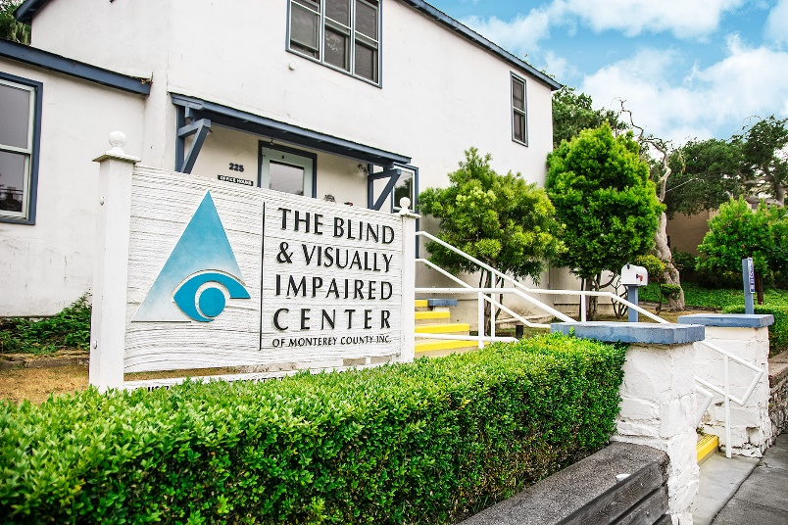
Braille Classes
Pacific Grove Braille Class: Second Tuesday of each month at 10:00 AM at 225 Laurel Avenue in Pacific Grove.

Salinas Braille Class: Fourth Tuesday of each month at 10:00 AM at 236 Monterey Street in Salinas.

Anyone interested in attending is urged to call The Blind and Visually Impaired Center at 831-649-3505.

Community Outreach
Community Outreach is a growing service offered by The Blind and Visually Impaired Center of Monterey County. We provide low vision training to service providers, attend health fairs, and present information sessions at senior living centers and in the wider community. To submit an event invite or demonstration request, contact Steven Macias, Executive Director, at 831-649-3505.

Contact Us
The Blind and Visually Impaired Center of Monterey County, Inc.
Address: 225 Laurel Avenue, Pacific Grove, California 93950
Telephone: 831-649-3505
Fax: 831-649-4057
Email: vision@blindandlowvision.org
Website: www.blindandlowvision.org
A MESSAGE FROM TOM GARDNER, BOARD PRESIDENT
As Board President of The Blind and Visually Impaired Center of Monterey County, I work directly with other members of the Board and our Executive Director, Steven Macias, to ensure all client and staff needs are met. Today, I can proudly say as I have every year, that those needs are being met.

The Blind and Visually Impaired Center office in Pacific Grove recently underwent a major interior renovation thanks to the generosity of Manitou Fund and The McNeely Family. I would encourage everyone in the community to visit and see the changes. The assistive technology room, reception, waiting room and audio library have been completely redone.

The Center is also a part of Monterey County GIVES! this year. We have set a high goal of $50,000 to directly benefit our clients with everyday assistive technology. This funding makes a significant difference in the service we can provide.

We are also gearing up for our Fall Gala and Silent Auction at the Monterey Marriott. We have our keynote speaker, Supervisor Wendy Root Askew, confirmed to deliver the keynote address. The event, taking place on Saturday, November 12, 2022, is sure to be a night to remember. If you have not already done so, purchase your seat by calling 831-649-3505. Seats are $150 per person and all proceeds directly benefit The Blind and Visually Impaired Center.

Our impactful work is not possible without your generous support. On behalf of the Board of Directors and I, we thank you.

Sincerely,
Tom Gardner
Board President

BOARD MEMBER SEARCH
The Blind and Visually Impaired Center of Monterey County is actively seeking Board Members. This volunteer Board meets six times per year at our Pacific Grove office and guides The Center towards its mission of empowering the blind and visually impaired toward independent living through education, support services and skills training.

To express your interest, please contact Steven Macias, Executive Director at 831-649-3505 or by email at steven@blindandlowvision.org.

NEW STAFF MEMBER RAVEN THOMPSON
The Blind and Visually Impaired Center is pleased to welcome Raven Thompson, who joined our office back in May 2022. Ms. Thompson joins us with a wealth of administrative knowledge. She is in our Pacific Grove office on Tuesdays and Thursdays.
SAVE THE DATE - FALL GALA AND SILENT AUCTION – NOVEMBER 12, 2022; 4:30 PM to 8:30 PM
On Saturday, November 12, 2022, The Blind and Visually Impaired Center of Monterey County will host our Fall Gala and Silent Auction at the Monterey Marriott, Ferrantes Bay View Room. Individual seats cost $150 per person. Sponsor tables cost $3,000 and includes seating for eight guest at your private, preferred view table, name recognition in the program, The Blind and Visually Impaired Center website and newsletter, and verbal recognition by our Master of Ceremonies during the event. Supervisor Wendy Root Askew will serve as our keynote speaker.

The Fall Gala and Silent Auction serves as the major fundraising event for The Blind and Visually Impaired Center, which is a 501(c)3 non-profit agency that has provided free services since 1971 to Monterey County residents who are visually impaired. Our mission is to empower these individuals toward independent living through education, support services, and skills training.

Details of the event are as follows:
4:30 P.M. to 5:45 P.M. Hors D‘oeuvre, reception and silent auction with entertainment
5:45 P.M. to 6:15 P.M. Keynote Speaker address, awards, and sponsor recognition
6:15 P.M. to 7:45 P.M. Three course dinner with plated short ribs or Mahi Mahi entrees
7:45 P.M. to 8:15 P.M. Live auction and coffee/tea service
8:15 P.M. to 8:30 P.M. Departure

To serve as a sponsor, please contact Steven Macias, Executive Director, at 831-649-3505.

A MESSAGE FROM STEVEN MACIAS, EXECUTIVE DIRECTOR
It’s been a busy year for us at The Blind and Visually Impaired Center. Our office in Salinas, located at 236 Monterey Street, allows us to host support groups twice a month, braille classes, and offer assistive technology showcases. In August, The Center underwent a major interior transformation thanks to Manitou Fund and The McNeely Family, whose kind generosity allowed us to create a more accessible and professional space.

We are also in the midst of planning for our Fall Gala and Silent Auction, which we are pleased to present at The Monterey Marriott, Ferrantes Bay View Room. This event will serve as a major fundraiser for The Center. Seats are $150 per person, and I encourage everyone to attend.

Lastly, The Center is once again participating in Monterey County GIVES! In 2021, we raised over $32,738. This year, we set a goal of $50,000. But this goal can only become possible with your generous support. Please, give generously this year. Your support does make a difference.

Sincerely,
Steven Macias
Executive Director
MONTEREY COUNTY GIVES! – NOVEMBER 10 THROUGH DECEMBER 31
On Thursday, November 10, the Monterey County GIVES! campaign officially begins, with The Blind and Visually Impaired Center of Monterey County once again participating in this vital fundraising endeavor. This campaign runs until December 31, 2022 and greatly benefits The Center. Last year we raised $32,738.30. With your help, we can continue our mission to serve and empower our clients toward an independent life through education, support services and skills training. This campaign serves as one of the major sources of funding for The Blind and Visually Impaired Center, the only public low vision clinic in Monterey County.

In 2000, the Weekly supported the nonprofit community when it established the Monterey County Weekly Community Fund, a donor advised fund of the Community Foundation for Monterey County. In 2009, Monterey County Gives! was launched, focused on an annual appeal to the Weekly’s generous readers for year-end donations. In that first year, $417,000 was raised and granted. The Weekly has built on that success each year, and with the Monterey Peninsula Foundation joining as a partner in 2015, the campaign has shown the power of philanthropy in Monterey County.

To donate online, please visit www.montereycountygives.com/blind to make your donation. You can also mail a check directly to:

Community Foundation for Monterey County
Attn: MCGives!
2354 Garden Road
Monterey, California 93940

Checks MUST be made payable to “Community Foundation for Monterey County” (or “CFMC”, or “CFMC/MCGives”). Please remember to include your full name, address, and in the memo section of the check write “Blind and Visually Impaired Center” (or “BVIC”).

Alternatively, you can send your check to The Blind and Visually Impaired Center and we will send it to The Community Foundation for Monterey County.

The Blind and Visually Impaired Center of Monterey County encourages everyone to give generously this year to allow us to continue to serve and empower our clients toward an independent life through education, support services and skills training. Your contribution has the ability to greatly impact someone’s life.

2022 SENIOR RESOURCE FAIR
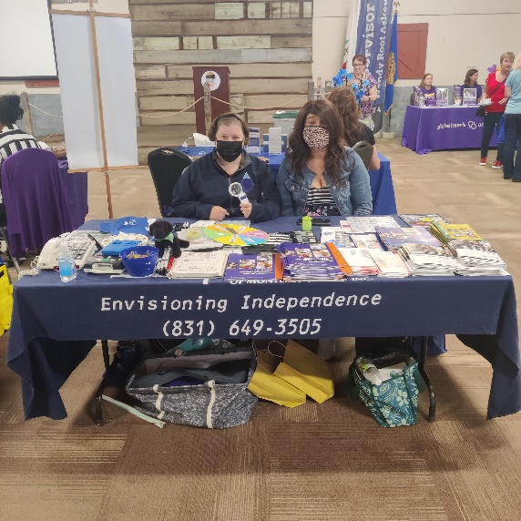
On Thursday, September 1, 2022, The Blind and Visually Impaired Center participated in the 2022 Senior Resource Fair at the Monterey County Fairgrounds. The event, attended by hundreds, showcased all the regional senior services available. The Blind and Visually Impaired Center booth, staffed by Karen Levin and Marisa Vallejo, showcased assistive technology and devices, and provided handouts to interested individuals.

To submit an event invite or demonstration request, contact Steven Macias, Executive Director, at 831-649-3505.

AMAZON SMILE
Did you know you could shop Amazon AND support The Blind and Visually Impaired Center of Monterey County at the same time?

Through smile.amazon.com, 0.5% of you Amazon Smile purchase goes directly to The Blind and Visually Impaired Center. To get started, visit smile.amazon.com, type in “The Blind and Visually Impaired Center of Monterey County,” and select it as your nonprofit. Then shop.

CENTER RECEIVES $17,000 COMMUNITY IMPACT GRANT
The Blind and Visually Impaired Center of Monterey County received a $17,000 Community Impact Grant from Len and Gundy DuVall Fund of the Community Foundation for Monterey County. This grant provides operating support for The Center’s Salinas office, located at 236 Monterey Street. “We appreciate the support of the Len and Gundy DuVall Fund of the Community Foundation for Monterey County to continue our operations and expansion in Salinas,” said Steven Macias, Executive Director. “Without this funding, we would have a much harder time continuing our good work.”

WHITE CANE DAY – OCTOBER 14, 2022
On Friday, October 14, 2022, The Blind and Visually Impaired Center of Monterey County will be participating in White Cane Day. The purpose of this event is to raise awareness and recognize the achievements of individuals who are visually impaired who use white canes to travel.

Ken Hunter, past president and board member for The Blind and Visually Impaired Center, will lead the group throughout Pacific Grove where they will visit with merchants and enjoy a lunch at Victorian Corner Restaurant following the excursion.

OFFICE REVISION
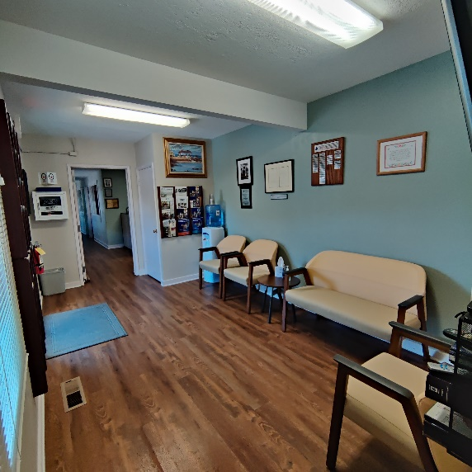
The Blind and Visually Impaired Center of Monterey County would like thank Manitou Fund and The McNeely Family for their generosity in supporting our work. Their ongoing contributions have allowed us to offer services to hundreds of residents of Monterey County and provide the essential education, skills training, and services to help these individuals lead an independent life,

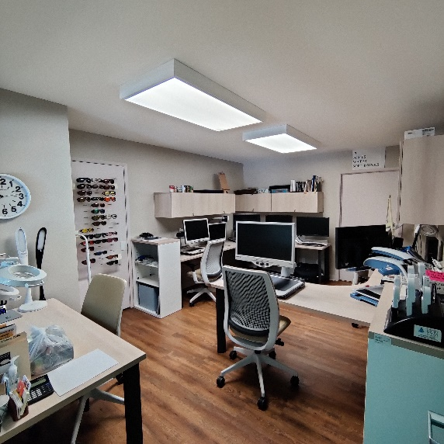
With funding from Manitou Fund and The McNeely Family, The Blind and Visually Impaired Center was able to procure new office furniture, including new interior paint and lighting. “We deeply appreciate the efforts of the McNeely Family,” says Steven Macias, Executive Director. With their contribution, and with the help of Peninsula Business Interiors, our office has a brand-new feel. Staff, clients, and visitors really enjoy the environment.
The Board of Directors thank Mr. McNeely for his generous contributions to this effort.

Most of the major changes were in the assistive technology room, reception, waiting room and audio library. Upstairs, one of the rooms was converted into a conference room that can comfortably seat 12 individuals.
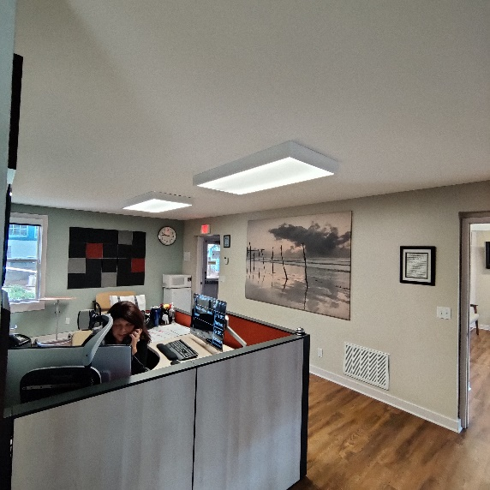
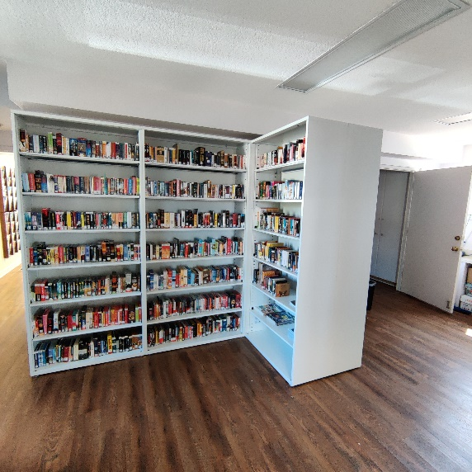
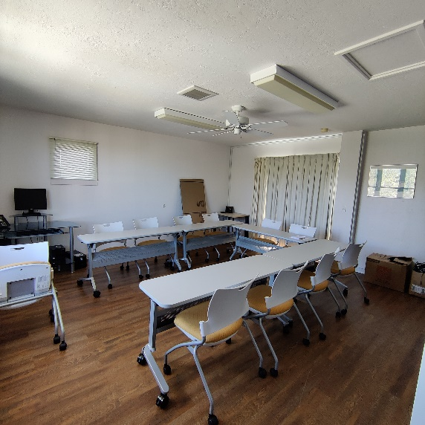

The Blind and Visually Impaired Center of Monterey County would like to thank all who have contributed to our work. Your contributions have allowed us to provide services to hundreds of residents of Monterey County and provide the essential education, skills training, and services to help these individuals lead an independent life.

“Alone we can do so little; together we can do so much.”
-Helen Keller

BOARD MEMBERS AND VOLUNTEERS
The Blind and Visually Impaired Center of Monterey County is proud to recognize their current board members, staff and volunteers:
Board of Directors

• Tom Gardner, President
• Dr. Celia Barberena, Vice-President
• Alissa Whittle, Treasurer
• Sonja Jackson, Secretary
• Dr. Gary Gray
• Randy Henson
• Toula Hubbard
• Dr. Ken Hunter

Staff

• Steven Macias, Executive Director
• Martha Burgoon, Blind Rehabilitation Specialist/Low Vision Clinic Coordinator
• Megan Carter, OD, Low Vision Optometrist
• Karen Levin, Vision Rehabilitation Specialist
• Fred Sterenberg, Finance and Compliance Coordinator
• Jenny Swad, Orientation and Mobility Specialist
• Raven Thompson, Receptionist
• Marisa Vallejo, Intake Assistant/Receptionist
• Katie Wendt, OD, Low Vision Optometrist

Volunteers
• Madelayne Shadkam

The Blind and Visually Impaired Center
Non-Profit Org
US Postage
PAID
Permit No. 228
Pacific Grove, CA
of Monterey County, Inc.
225 Laurel Avenue
Pacific Grove, California 93950

831-649-3505
vision@blindandlowvision.org

Ways to Donate
You can make a tax-deductible gift online through PayPal at www.blindandlowvision.org/give/ or by mail to: The Blind and Visually Impaired Center of Monterey County, Inc.
225 Laurel Avenue
Pacific Grove, California 93950

Federal Tax ID #23-7221588

Endowment Fund
Did you know that over the years many of our clients and donors have left a bequest to The Center? Their gifts have been used to establish a modest endowment fund. The Board uses earnings from the fund to expand programming, purchase equipment, or supplement the annual operating budget.

Chariots for Charity
Operated by the Monterey Old Capitol Lions Club, Chariots for Charity vehicle donations support The Blind and Visually Impaired Center of Monterey County with cash donations from the sales of donated vehicles. Operated since 1985, the Chariots program has raised more than $400,000 to support The Center.

For more information or to donate a vehicle, contact Russ Hatch at 831-659-5360.

