|  |
| --- |
|  **BLINDFOLD** |
| 225 Laurel Avenue, Pacific Grove, California 93950 831-649-3505 www.blindandlowvision.org |

**Spring 2023**

**CLASSES AND SUPPORT GROUPS**

**Peer Support Groups**

**Pacific Grove Peer Support Group**

First and third Tuesdays of each month at 10:00 AM at 225 Laurel Avenue.

**Salinas Peer Support Group**

Second and fourth Thursdays of each month at 10:00 AM at 236 Monterey Street.

**Soledad Peer Support Group**

First and third Monday of each month at

10:00 AM at 1505 Metz Road in Soledad.

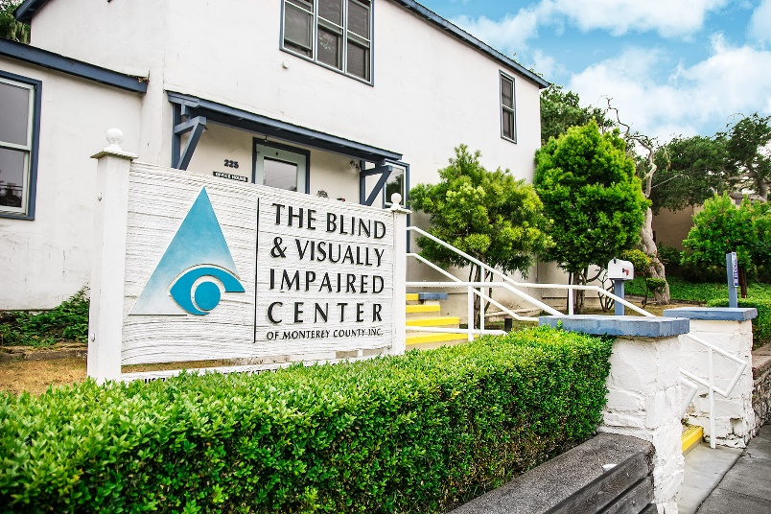

**Braille Classes**

**Pacific Grove Braille Class**: Second Tuesday of each month at 10:00 AM at 225 Laurel Avenue in Pacific Grove.

**Salinas Braille Class**: Fourth Tuesday of each month at 10:00 AM at 236 Monterey Street in Salinas starting May 24, 2022.

Anyone interested in attending is urged to call The Blind and Visually Impaired Center at 831-649-3505.

**Fitness Class**

**Fitness Instruction**

Every Tuesday at 1:00 PM at

225 Laurel Avenue in Pacific Grove.

**Contact Us**

The Blind and Visually Impaired Center of Monterey County, Inc.

Address: 225 Laurel Avenue, Pacific Grove, California 93950

Telephone: 831-649-3505

Fax: 831-649-4057

Email: vision@blindandlowvision.org

Website: [www.blindandlowvision.org](http://www.blindandlowvision.org)

**A MESSAGE FROM TOM GARDNER, BOARD PRESIDENT**

First and foremost, let me begin by thanking all of you who have contributed either time or financial means to continue to make The Blind and Visually Impaired Center a growing nonprofit. We concluded 2022 with our Fall Gala and Silent Auction, as well as having raised the most money ever since we began our participation in Monterey County GIVES!

Now, in 2023, in addition to support groups in Pacific Grove and Salinas, we began hosting a support group in Soledad on March 20th. This new support groups meets the first and third Monday of the month at the Hartnell College – Soledad Education Center from 10:00 AM to 11:30 AM. We also began a fitness class every Tuesday from 1:00 PM to 2:00 PM. All are free and all are welcome to attend.

As we continue to expand, our impactful work is not possible without your generous support. On behalf of the Board of Directors and I, we thank you for your support.

Sincerely,



Tom Gardner

Board President

**BLIND AND VISUALLY IMPAIRED CENTER RAISES $47,676.19 THROUGH MONTEREY COUNTY GIVES!**

On behalf of the Board of Directors, staff and especially the clients of The Blind and Visually Impaired Center of Monterey County, I am writing to thank to you for your generous donations made through the Monterey County GIVES! annual campaign. This year, the Center received $47,676.19, the most raised in the Center’s history since our participation in this fundraising event, and almost $15,000 more than the previous year. Even with financial hardships occurring, you still generously donated. For that, we extend our sincerest appreciation. Your contribution will continue to allow us to provide services at little to no cost to residents throughout Monterey County who are living with vision loss.

I send my best wishes and, again, thank you for your support through Monterey County Gives!

Steven Macias

Executive Director

**NEW FITNESS CLASS AND SUPPORT GROUP**

**Fitness Instruction Class**

Every Tuesday

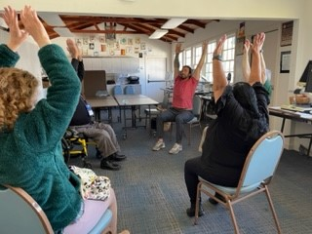1:00 PM to 2:00 PM

Starting Tuesday, March 7th, the Pacific Grove office will host a Fitness Instruction Class led by Fitness Instructor Nick Villareal. This class, which will be held Tuesdays from 1:00 PM to 2:00 PM on a weekly basis, is designed for all levels of fitness, and will focus on simple movements to increase muscle strength and balance, primarily utilizing bodyweight workouts to create effective exercises. Free. All are welcome to attend.

**Soledad Support Group**

First and Third Monday of the Month

10:00 AM to 11:30 AM

Starting Monday, March 20th, The Blind and Visually Impaired Center will host a new support group at the Community Room at Hartnell College-Soledad Education Center, located at 1505 Metz Road in Soledad. This support group, which will be held on the first and third Monday of the month from 10:00 AM to 11:30 AM, will be led by staff member Marisa Vallejo in a bilingual setting. Free. All are welcome to attend.

To learn more information, call The Blind and Visually Impaired Center of Monterey County at 831-649-3505.

**AMAZON SMILE**

Did you know you could shop Amazon **AND** support The Blind and Visually Impaired Center of Monterey County at the same time?

Through smile.amazon.com, 0.5% of you Amazon Smile purchase goes directly to The Blind and Visually Impaired Center. To get started, visit smile.amazon.com, type in “The Blind and Visually Impaired Center of Monterey County,” and select it as your nonprofit. Then shop.

**BOARD MEMBER SEARCH**

The Blind and Visually Impaired Center of Monterey County is actively seeking Board Members for one-year terms. This volunteer Board meets six times per year at our Pacific Grove office and guides the Center towards its mission of empowering the blind and visually impaired toward independent living through education, support services and skills training.

To express your interest, please contact Steven Macias, Executive Director at 831-649-3505 or by email at steven@blindandlowvision.org.

**A MESSAGE FROM STEVEN MACIAS, EXECUTIVE DIRECTOR**

As we move into 2023, I am excited to announce our new programs at The Blind and Visually Impaired Center. We are now hosting a support group in Soledad and a new fitness class, while still hosting support groups and braille classes in Pacific Grove and Salinas. With the addition of our Soledad support group, we now offer a support group within a 30-minute drive time of almost anywhere in Monterey County.

This year, we also brought in the most money ever for Monterey County GIVES! I appreciate all those who donated this year, your support makes a difference.

As we look ahead, the Fall Gala and Silent Auction is set to be held on Saturday, November 18 at the Monterey Marriott, Ferrantes Bay View Room. If you were unable to join us last year, I encourage you to join us this year for this wonderful evening. We are also planning to return an arts program to the Center for our clients to enjoy.

All these programs are made possible through your generous contributions. So please, continue to give generously. Your gift can greatly improve the life of someone you may know.

If you have any questions, comments or thoughts on how we can best improve the lives of those in our community with vision impairment, please contact me directly at 831-649-3505 or by email to steven@blindandlowvision.org.

Sincerely,



Steven Macias

Executive Director

**MONTEREY-SALINAS TRANSIT SENIOR DAY – MAY 23, 2023**

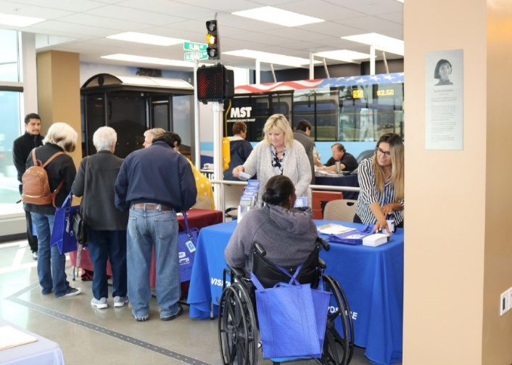Monterey-Salinas Transit will be hosting their Fourth Annual Senior Transit Day at the Mobility Service Center in Salinas, located at 15 Lincoln Avenue on Tuesday, May 23rd from 10:00 AM to 1:00 P.M. All are welcome to attend and receive information from local agencies on resources available for older adults and learn about transit services for seniors. Legal Services for Seniors, Deaf and Hard of Hearing Center, The Blind and Visually Impaired Center, Alliance on Aging, and ITN Monterey County are just a few of the organizations participating.

For more information, contact Monterey-Salinas Transit directly at 1-888-678-2871.

**PRODUCT SHOWCASE: HUMANWARE VICTOR READER STREAM 3**

Featuring a fully tactile interface, the Victor Reader Stream is a handheld digital audio player to enjoy your media content. This assistive device lets you listen to books, newspapers, web radio, music, podcasts, and other online resources. Simple to use, the Stream talking book player packs all your media into place and gives 15 hours of battery life, leaving more time to enjoy media content.

With Victor Reader Stream, it’s easy to take your books, music, and more wherever you go. Imagine being able to listen to the latest novels, magazines, or your favorite music, podcasts, and your own voice recordings, all in the palm of your hand. With its sleek, compact design and easy-to-grip edges, the digital media player gives you hours of listening wherever you are and superior text-to-speech experience in multiple languages.

Features include direct download or transfer books from dedicated libraries, internet radio streaming or transfer content to listen offline., audio recording, simple navigation, browse DAISY books by chapter, section, or phrase and more.

**MONTEREY-SALINAS TRANSIT TRAVEL TRAINING PROGRAM**

Monterey-Salinas Transit (MST) offers free fixed-route travel training to teach interested individuals, groups, and organizations how to ride the bus safely and independently.

Buses and transit centers are thoroughly cleaned each night using hospital grade disinfectants, and hand-held foggers are used to spray germicide inside buses to decontaminate the coach. Hand sanitizer dispensers have been installed on all buses to help keep passenger hands clean, windows are kept open to allow air inside buses to be refreshed quickly, and visual reminders have been placed throughout the bus asking everyone to maintain a safe distance from other passengers.

After training, you will discover how easy it is to plan a trip; understand route maps, stops, schedules and landmarks; get to and from bus stops safely; get on and off the bus safely; pay fares and purchase passes; ride a specific route; transfer to other buses; and if needed, use a mobility device when riding.

Not only are passengers gaining independence, but they are also saving money, enjoying the opportunity to meet other passengers, making a positive impact on the environment, and gaining valuable time to relax while leaving the driving to MST.

Contact the MST Mobility Services Center to schedule your training at 831-264-5886.

**FALL GALA AND SILENT AUCTION**

Plans are underway for The Blind and Visually Impaired Center of Monterey County’s Fall Gala and Silent Auction. The tentative date is November 18, 2023, at the Monterey Marriott Ferrantes Bay View Room. Ticket prices are tentatively set at $150 per person and includes a three-course meal, wine, and entertainment.

If you would like to discuss ways to donate to the Fall Gala and Silent Auction, or for sponsorship opportunities, contact Steven Macias, Executive Director, at 831-649-3505.

**REMEMBERING BOARD MEMBER SONJA JACKSON**

Sonja C. Jackson lived an active life in her beloved community of Pacific Grove. She was born on September 20, 1947, in Malden, Massachusetts and passed away on January 1, 2023.



In her early days on the Peninsula, Sonja worked for the Federal Civil Service.

During the 1970’s, Sonja and her husband, “J”, purchased their home in Pacific Grove. In those early years when Sonja’s vision began to fail, J began painting their home with colorful and artful butterflies. J continued with this project, and, soon their home became known as “The PG Butterfly House” and is still of interest to visitors.

During the 1990’s, Sonja’s failing vision brought her to The Blind and Visually Impaired Center for Monterey County. Soon, she was elected to the Board of Directors where she served several years as Secretary to the Board. She also participated in group activities there, including a support group for those with ailing vision. She was the first in the group to acquire a Guide Dog named Melanie. When Melanie could no longer guide, she was given Pine, a yellow Labrador Retriever. Pine met many in our community as she guided Sonja in her neighborhood.

Sadly, on New Year’s Day, Sonja died of complications from an earlier stroke. She was preceded in death by her husband, her parents, as well as her brother and sister.

Gifts of remembrance can be made to Guidedogs for the Blind in San Rafael, The Blind and Visually Impaired Center of Monterey County, Peace of Mind Dog Rescue in Pacific Grove, or to Meals on Wheels of the Monterey Peninsula.

The Blind and Visually Impaired Center will always remember her dedication to the community.

**THE HUB – ALLIANCE ON AGING FARMER’S MARKET**

Alliance on Aging hosts a Farmer’s Market the second and fourth Thursday of the month from 10:00 AM to 12:00 noon. Come shop the fresh, affordable farmer’s market quality produce at The HUB, located at 236 Monterey Street in Salinas. While you’re there, feel free to join us for our Salinas support group that coincides with the farmers’ market right across the hall.

For more information, call Alliance on Aging at 831-646-5050 or check their website at www.allianceonaging.org/hub/ for other senior related events.

**ETIQUETTE TO OFFER PEOPLE WHO ARE BLIND**

If you see a blind person who seems to need help, offer your services. Speak directly to them, not through a third party. Identify yourself and let him or her know you’re talking to them. If your help is refused, don’t be offended.

If you assist an individual who is blind, offer your arm. They will take your arm, and this will allow them to take your elbow and grasp it like a letter “c,” or like holding a soda can.

When you’re leaving a person who is blind, say so. “I’m going to get some lemons in the produce section and will be back in 5 minutes” is an example phrase. Don’t leave the person stranded. For another example, tell them that there is a Starbucks located at the front of the store in the middle that has chairs and tables. Take the person there to wait where he or she can sit down.

When giving directions to a blind person it is important to give them specific directions (turn to your right). Don’t point and say, “Over there.” It is important to provide specific names (streets, buildings) to places where the individual is familiar with.

When serving or eating with a person who is blind, tell him or her what is being served, (clock technique). Explain that the potatoes are at the 6 o’clock position and that the meat is at the 12 o’clock position.

It is important when working with a blind individual to leave things where you find them. Moving items for the visually impaired makes it harder for them to locate the object and they will be searching until they find it.

Remember that common sense and sensitivity are important when interacting with visually impaired individuals.

For more information, please contact The Blind and Visually Impaired Center at 831-649-3505.

**The Blind and Visually Impaired Center**

Non-Profit Org

US Postage

PAID

Permit No. 228

Pacific Grove, CA

**of Monterey County, Inc.**

225 Laurel Avenue

Pacific Grove, California 93950

831-649-3505

vision@blindandlowvision.org

**Community Outreach**

Community Outreach is a growing service offered by The Blind and Visually Impaired Center of Monterey County. We provide low vision training to service providers, attend health fairs, and present information sessions at senior living centers and in the wider community. To submit an event, invite or demonstration request, contact Steven Macias, Executive Director, at 831-649-3505.

**Ways to Donate**

You can make a tax-deductible gift online through PayPal at www.blindandlowvision.org/give/ or by mail to: The Blind and Visually Impaired Center of Monterey County, Inc.

225 Laurel Avenue

Pacific Grove, California 93950

Federal Tax ID #23-7221588

**Endowment Fund**

Did you know that over the years many of our clients and donors have left a bequest to the Center? Their gifts have been used to establish a modest endowment fund. The Board uses earnings from the fund to expand programming, purchase equipment, or supplement the annual operating budget.

**Chariots for Charity**

Operated by the Monterey Old Capitol Lions Club, Chariots for Charity vehicle donations support The Blind and Visually Impaired Center of Monterey County with cash donations from the sales of donated vehicles. Operated since 1985, the Chariots program has raised more than $400,000 to support the Center. For more information or to donate a vehicle, contact Russ Hatch at 831-659-5360.